Laurence Sgroi Apprentice Portfolio

Criteria
K1 | Describes all stages of the software development lifecycle | 1.a Introduction  1.b Agile Workflow  3.c SDLC
K3 | Describes the roles and responsibilities of the project lifecycle within their organisation, and their role | 1.a.ii Roles  1.b Agile Workflow  3.b Roles and Responsibilities
K4, S15 (Distinction + B7) | Describes methods of communicating with all stakeholders that is determined by the audience and/or their level of technical knowledge.  Distinction: Compares and contrasts the different types of communication used for technical and non-technical audiences and the benefits of these types of communication methods | 1.b Agile Workflow  6.f Mentoring
K5 | Describes the similarities and differences between different software development methodologies, such as agile and waterfall | 1.b Agile Workflow  3.d Software Development Methodology
K7 | Suggests and applies different software design approaches and patterns, to identify reusable solutions to commonly occurring problems (include Bespoke or off-the-shelf)  Distinction: Evaluates and recommends approaches to using reusable solutions to common problems. | 1.d.ii Evaluating  6.c Simplifying Setup
K8, S14 | Explains the relevance of organisational policies and procedures relating to the tasks being undertaken, and when to follow them including how they have followed company, team or client approaches to continuous integration, version, and source control | 1.f Release management  3.e Organisational policies  5 Cyber essentials
K10 | Applies the principles and uses of relational and non-relational databases to software development tasks | 1.c Database
K12 | Describes basic software testing frameworks and methodologies  Distinction: Evaluates the use of various software testing frameworks and methodologies and justifies their choice. | 1.e Testing and Quality Assurance  3.g Testing  4 BISA Testing
S2 | Explains, their own approach to development of user interfaces | 1.d.iv User Interfaces
S3 | Explains, how they have linked code to data sets | 1.c Database  6.e Linking Code
S5, S13 | Illustrates how to conduct test types, including Integration, System, User Acceptance, Non-Functional, Performance and Security testing including how they have followed testing frameworks and methodologies | 4 BISA Testing  3.g Testing  1.b Agile Workflow
S8 | Creates simple software designs to communicate understanding of the programme to stakeholders and users of the programme | 1.d.iii Interpreting Designs  3.h Tech Talk
S9 | Creates analysis artefacts, such as use cases and/or user stories to enable effective delivery of software activities | 1.b Agile Workflow  3.g.i Testing types
S17 | Explains, how they have interpreted and implemented a given design whilst remaining compliant with security and maintainability requirements | 6.d Authentication  1.g Security and Maintainability
B1 | Describes, how they have operated independently to complete tasks to given deadlines which reflect the level of responsibility assigned to them by the organisation’. | 1.b Agile Workflow  6.c Simplifying Setup
B4 | Illustrates how they have worked collaboratively with people in different roles, internally and externally, which show a positive attitude to inclusion & diversity. | 4 BISA Testing  2.a Sociocracy and Circles
B5 | Explains how they have established an approach in the workplace which reflects integrity with respect to ethical, legal, and regulatory matters and ensures the protection of personal data, safety and security. | 5 Cyber essentials  6.d Authentication
B6 | Illustrates their approach to meeting unexpected minor changes at work and outlines their approach to delivering within their remit using their initiative. | 1.f.iii Handling changes  3.f Unexpected
B7 | Explains how they have communicated effectively in a variety of situations to both a technical and non-technical audience. | 1.a.ii Roles  1.b Agile Workflow  6.f Mentoring  3.h Tech Talk
B8 | Illustrates how they have responded to the business context with curiosity to explore new opportunities and techniques with tenacity to improve solution performance, establishing an approach to methods and solutions which reflects a determination to succeed | 2 General Internal Activities
B9 | Explains how they reflect on their continued professional development and act independently to seek out new opportunities | 2 General Internal Activities

1 - Mental Health Foundation retheme 6
1.a - Introduction 6
1.a.i - Themes in Drupal Sites 6
1.a.ii - Roles 6
1.b -Agile Workflow and Collaboration 7
1.c - Database Structure and Management 10
1.c.i - Consideration of Non-Relational Databases 12
1.d - Design 13
1.d.i - Reusable Content and Design Patterns 13
1.d.ii - Evaluating Reusable vs. Bespoke Solutions 14
1.d.iii - Interpreting designs 14
1.d.iv - Approach to Developing User Interfaces 16
1.e - Testing and Quality Assurance 16
1.f - Release Management, Deployment, and Continuous Integration 17
1.f.i - Version Control and Tagging 18
1.f.ii -Deployment Process 18
1.f.iii - Handling Unexpected Changes and Initiative 18
1.g - Security and Maintainability 19
2 - General Internal Activities 21
2.a - Sociocracy and Circle Involvement 21
2.b - Drupal Development 21
2.c - Accessibility Development 22
3 - Agile.coop migration 23
3.a - Project Overview 23
3.b - Roles and Responsibilities 24
3.c - Software Development Lifecycle 24
3.d - Software Development Methodology 25
3.e - Organisational Policies and Procedures 25
3.f - Unexpected Challenges 27
3.g - Testing 27
3.g.i -Application of Testing Types and Frameworks 28
3.g.ii - Security Testing 28
3.h - Tech Talk 31
4 - BISA Accessibility user testing 32
4.a - Test Setup and Methodology 33
Figure 18 - Screenshot of the document used to record and notetake during user testing 33
4.b - Key Learning Outcomes 33
5 - Cyber Essentials 34
6 - 11ty - Drupal Starterkit 35
6.a - Introduction 35
6.b - Project Collaboration 36
6.c - Simplifying the Setup Process 36
6.d - Authentication for API Calls 37
6.e - Linking Code to Data Sets 38
6.f - Mentoring 39

1 - Mental Health Foundation retheme

1.a - Introduction
The MHF Retheme project involved developing a new theme for the Mental Health Foundation’s website. Agile Collective (AC) is a Drupal agency, and as such, Drupal is the primary tool we work with. I was primarily responsible for implementing the front-end theme based on designs provided in Figma, ensuring that the site met accessibility and cross-browser compatibility standards.

1.a.i - Themes in Drupal Sites
Themes are what make a Drupal website look the way it does. Theme developers use HTML, CSS, JavaScript, and other front-end assets to implement designs for a site. Each individual theme is a collection of files that define the presentation layer for an application.

1.a.ii - Roles
We worked in a cross-functional team consisting of a project manager, product owner, designer, another developer, and myself. The project followed a structured agile methodology with two-week sprints. Before each sprint, we held sprint planning meetings where we reviewed the backlog, selected tasks to move into the sprint, and estimated the effort required for each issue. This process helped prioritise work and ensure that the team was aligned on the scope and expectations for each sprint.
Throughout the project, we conducted regular stand-ups to monitor progress and discuss any blockers. At the end of each sprint, we held a sprint review to assess completed work, gather client feedback, and adjust the backlog as needed. My role involved working on tasks locally, conducting tests, and deploying changes through different environments: development, staging, and production.

1.b -Agile Workflow and Collaboration
Throughout the project, I actively participated in our agile workflow, which was organised into two-week sprints. Each sprint began with a planning session where the project manager, product owner, another developer, and I reviewed the backlog in GitLab and selected the most important tasks to be moved into the sprint. This ensured that everyone was aligned on priorities and had a clear understanding of the work ahead. The tasks were estimated, and I was responsible for providing estimates for the tickets assigned to me based on the complexity and requirements, reflecting my understanding of the software development lifecycle.
One of the key aspects of the Agile methodology that I appreciated was its iterative nature, allowing for continuous feedback and adaptation throughout the project. This stands in contrast to the Waterfall methodology, which follows a linear, sequential approach. In Waterfall, the project phases are distinct and must be completed before moving to the next, limiting flexibility. In Agile, we could pivot and adjust priorities based on client feedback at the end of each sprint, leading to a more responsive development process.
During our regular stand-up meetings, I communicated progress and blockers effectively, adapting my communication style based on the audience. When discussing updates with the client and project manager, who had less technical knowledge, I explained issues in a clear, less code-heavy way, focusing on outcomes such as improved accessibility, cross-browser compatibility, and design changes. This kept the discussions focused on the impact of the work rather than the technical details. However, when working with other developers, we discussed the technical aspects more deeply, including architectural decisions and code-specific challenges, enabling us to resolve issues faster.
In the later stages of the project, a new stakeholder, the Digital Experience Manager (DXM), joined the team. The DXM was responsible for managing content on the website but had limited experience with our agile process and ticketing system in GitLab, via a kanban board. This required me to adjust my communication style again, providing detailed explanations and demonstrations on how to use GitLab to track and manage issues. This form of communication was more hands-on and instructional, tailored to their specific needs and technical understanding. By contrast, communication with the product owner, who was already familiar with GitLab, was more focused on clarifying progress and resolving high-level questions about functionality and scope.
Adapting my communication approach depending on the technical knowledge of each stakeholder was critical in keeping the project on track. For non-technical audiences, explaining work in simple, outcome-focused terms ensured clarity and alignment with our goals. For technical peers, using more precise, code-focused discussions allowed us to resolve issues efficiently.
For each ticket I created analysis artefacts such as a comprehensive definition of done and acceptance criteria. This practice was crucial for ensuring that all stakeholders, including developers and project managers, had a clear understanding of the task’s requirements and when a ticket could be considered complete.
The definition of done typically outlined the essential steps that needed to be completed, such as code implementation, testing, peer reviews, and documentation updates. The acceptance criteria specified the exact conditions that the final output needed to meet, such as:
- Cross-browser compatibility, verified through BrowserStack.
- Compliance with accessibility standards.
- Visual components matching Figma designs.
These elements were documented directly in the ticketing system (GitLab), making it easy for team members to track progress and ensure consistency. Including acceptance criteria also facilitated smoother handoffs and helped maintain alignment during sprint reviews, as everyone had a shared understanding of the expected outcomes.
Once I completed the development of a task, I would move it into the "Testing" lane on our GitLab Kanban board and conduct thorough testing. This included using BrowserStack to check functionality and styling across different browsers and devices, see figure 1, and ensuring the acceptance criteria, see figure 2, were met. Meeting these criteria was essential to ensure that the website was accessible, reliable, and performant across a range of environments.
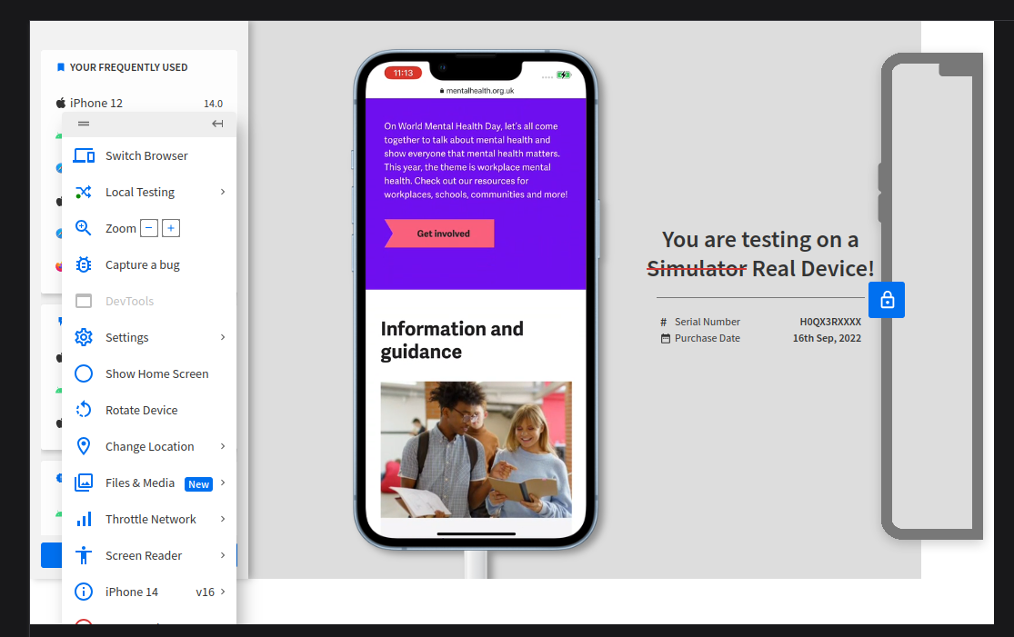
Figure 1 - Cross browser and device testing on BrowserStack

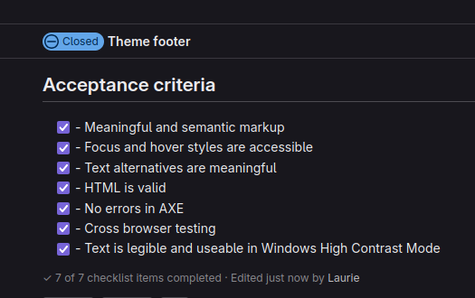
Figure 2 - Screenshot of the acceptance criteria section of a ticket in Gitlab

After passing my own cross-browser and accessibility tests, I submitted the task for a peer review. This peer review process allowed another developer to check my code for quality and compliance with coding standards before it was merged into the development environment. Once merged, the client would review and approve the work before it was deployed to staging and then to production.
At the end of each sprint, we held a sprint review where the team demonstrated the work completed during the sprint. This provided the client with an opportunity to give feedback and make adjustments to the next sprint’s priorities. This iterative process ensured continuous collaboration and allowed us to adapt the project’s direction based on client feedback and new requirements.

1.c - Database Structure and Management
In the MHF Retheme project, we used MariaDB, a relational SQL database which is a fundamental aspect of Drupal's architecture.We structured our content in the database through various content types and associated fields, see figure 3, allowing for organised and efficient management of site data.
There were multiple content types to cater to different sections of the website, including blogs, news, and landing pages. Each content type was carefully designed to meet specific project requirements, ensuring that the data stored was relevant and easily manageable.
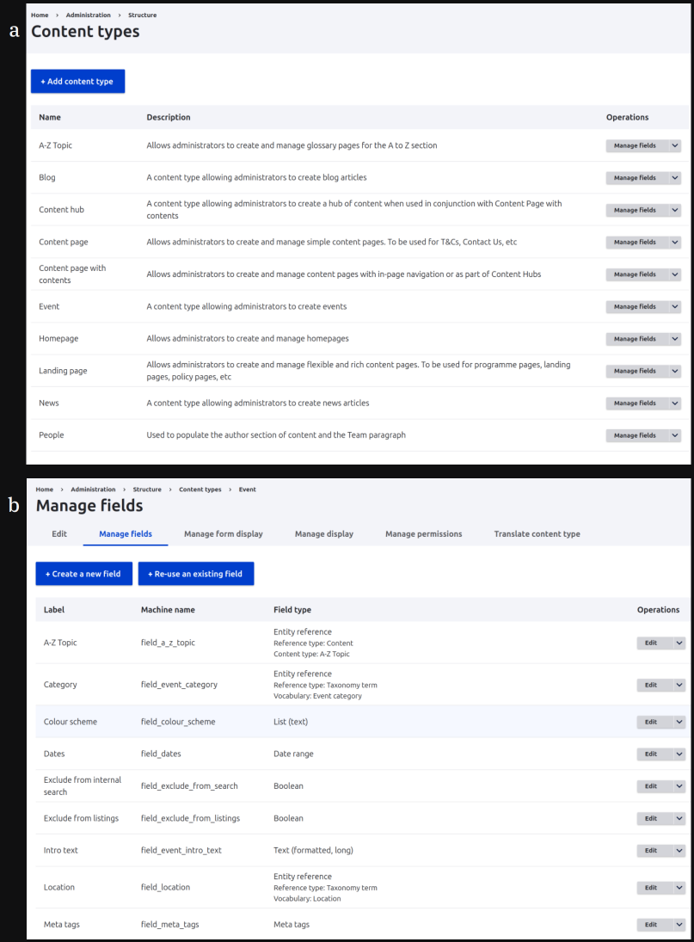
Figure 3 - a ) Content Types and b) Fields configuration for Event type in Drupal
The relational nature of the SQL database enabled us to establish meaningful relationships between different content types. This structure facilitated efficient querying and data retrieval, ensuring that the website functioned smoothly and that users could access content quickly.
A practical example of linking code to data involved updating an existing Drupal View, see figure 4, for the news page. I reconfigured the view to ensure it pulled the correct content from the database, filtering for published news items while excluding those marked to be hidden. This setup allowed the site to dynamically display the latest news articles as teasers, complete with titles and summaries, directly from the database.
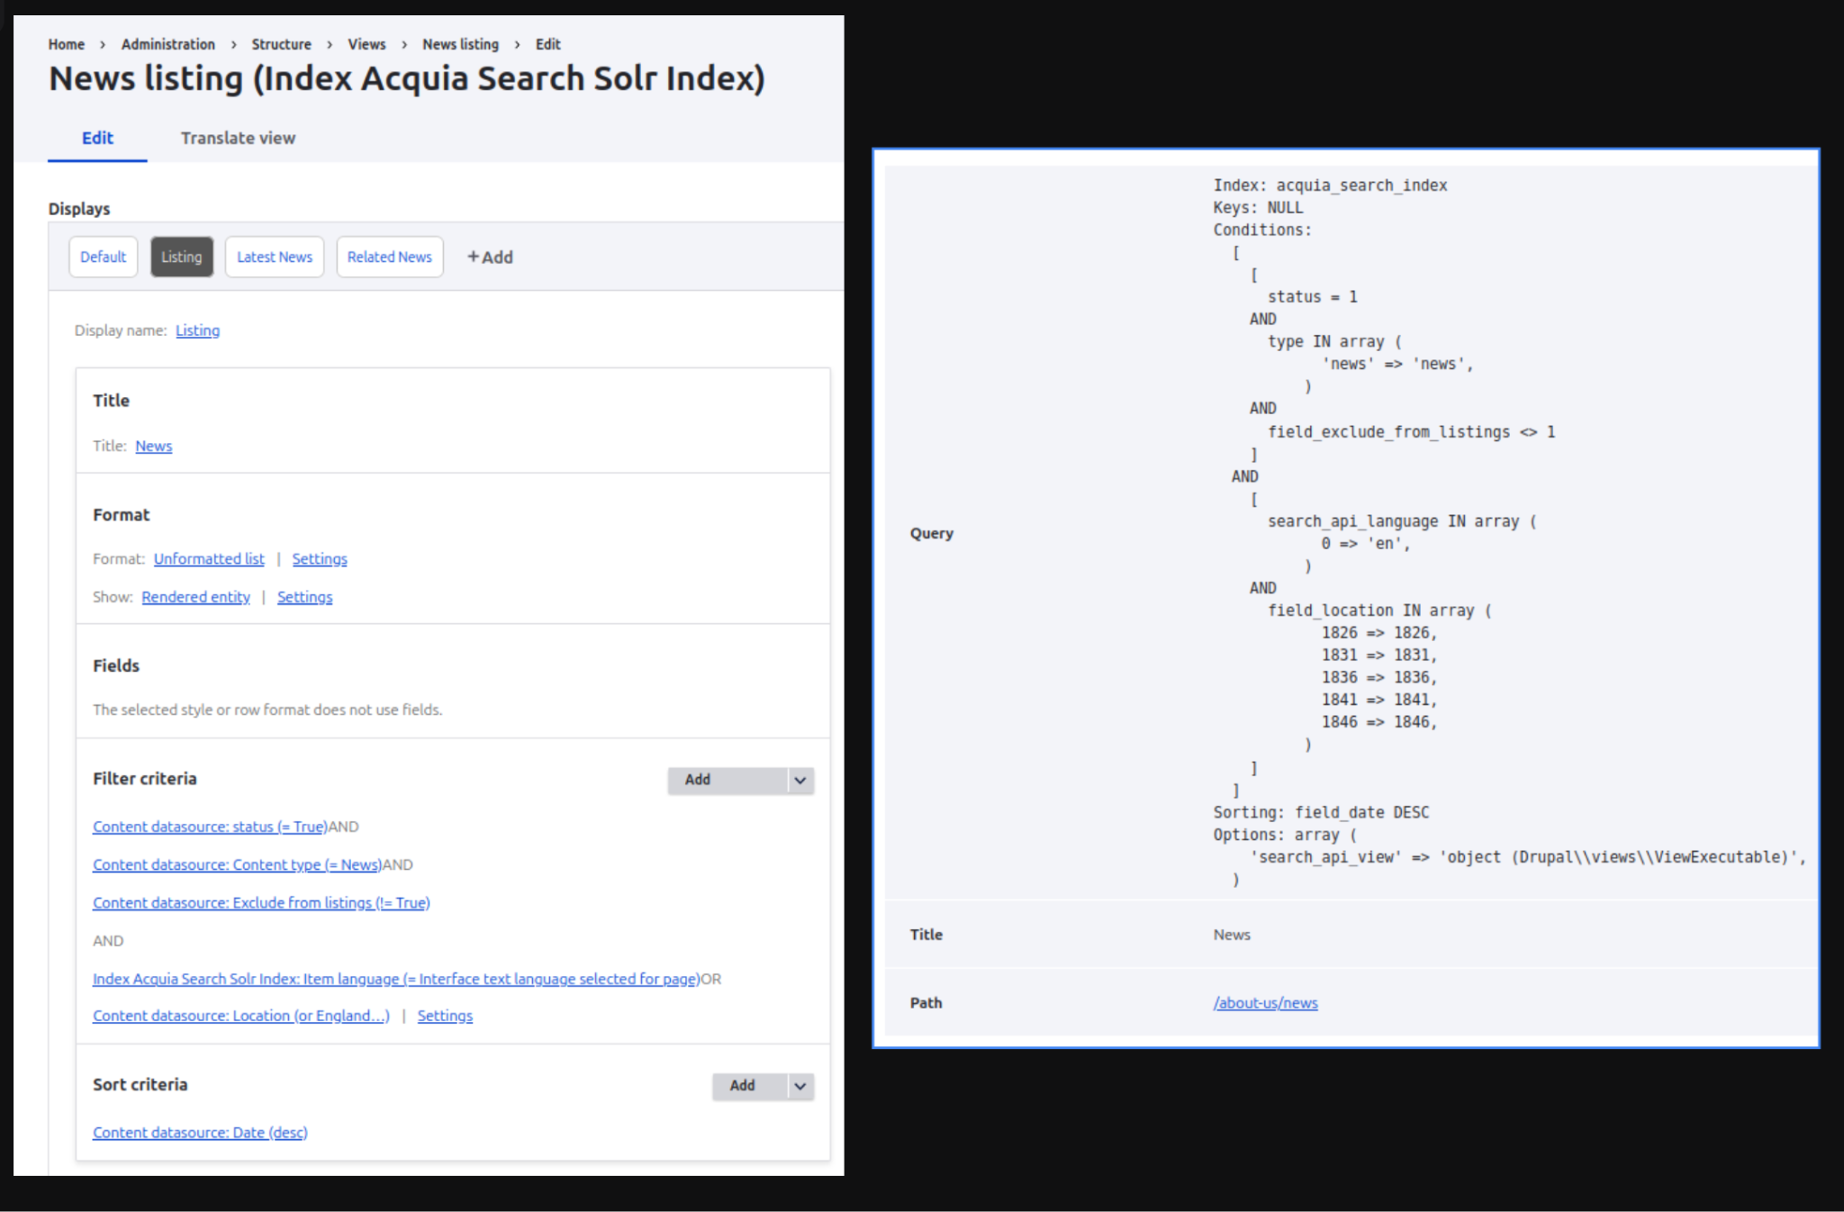
Figure 4 - Screenshot of the News listing drupal view and associated query.
To maintain an accurate local development environment, I regularly imported an up-to-date version of the production database from Acquia. Acquia provides automated database backups available for download, and I would use lando db-import to bring this data into my local setup. This approach ensured my local site accurately mirrored the production content, allowing me to test features and updates against the latest data. By doing so, I could verify that changes would function correctly when deployed, providing quality control early in the development process.
Overall, the careful design and management of the database schema not only supported the development process but also ensured that the website was scalable and maintainable, in line with the project's goals.

1.c.i - Consideration of Non-Relational Databases
While we did not use a non-relational (NoSQL) database for this project, I am familiar with their principles and applications. Non-relational databases, such as MongoDB, are often used in projects where data is more loosely structured or when horizontal scaling across distributed systems is required. These databases store data in formats like JSON or key-value pairs, allowing for greater flexibility in handling unstructured or semi-structured data.
In a project with highly dynamic content, or where real-time data processing and scalability were critical (e.g. a large-scale social media platform or an application with diverse data sources), a non-relational database could be advantageous. However, for the MHF project, the structured content model and the need for clearly defined relationships between data types made a relational SQL database the most appropriate solution.

1.d - Design

1.d.i - Reusable Content and Design Patterns
To enhance flexibility, I implemented the Paragraphs module, which allowed us to create reusable content components. This module acted as a design pattern by enabling modular and reusable templates for sections like accordions, images, and two-column layouts, see figure 5. The reusable design of these Paragraphs ensured consistency across various parts of the site, while simplifying future updates. For example, when I needed to make changes to a specific paragraph template, the updates would automatically apply to all instances where that paragraph was used, greatly reducing manual effort.
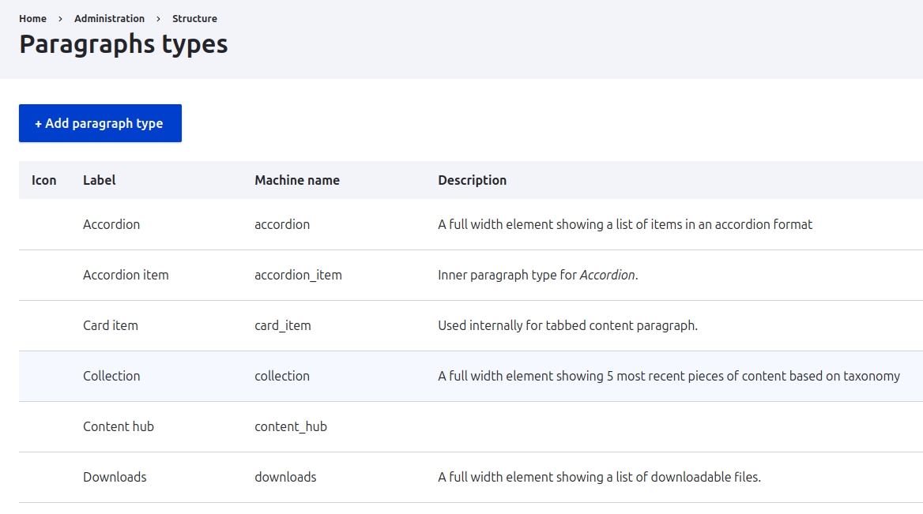Figure 5 - Some of the paragraph types used in the project.
By suggesting and applying reusable software design approaches like the Paragraphs module, I identified a scalable solution to common content management problems, such as maintaining uniformity across the site while allowing for flexible, dynamic layouts. This approach minimised duplication and improved the maintainability of the codebase.

1.d.ii - Evaluating Reusable vs. Bespoke Solutions
In considering whether to use off-the-shelf solutions like Paragraphs or build bespoke components from scratch, both options were evaluated. I determined that using the existing Paragraphs module provided a more efficient, maintainable solution. Bespoke solutions could have offered more custom functionality, but the Paragraphs module offered robust, reusable components that met our needs without the overhead of custom development. This balance allowed us to deliver a scalable solution within the project's timeline, while ensuring flexibility for future enhancements.

1.d.iii - Interpreting designs

There were instances where not all design details were provided, especially for components with optional fields, like the quote paragraph which had optional name, organisation and image fields. To address this, I created simple mockups to visualise how these components would appear under different configurations (e.g., with or without an image or organisation field), see figure 6. These mockups served as preliminary designs to bridge the gap between the provided Figma files and the final implementation.
I shared these mockups with both the client and design team to confirm that they met the project's visual and functional expectations. This step ensured that stakeholders understood the proposed layout, allowing for feedback before any significant development work began. The feedback loop minimised potential rework and aligned the development with client expectations early in the process.

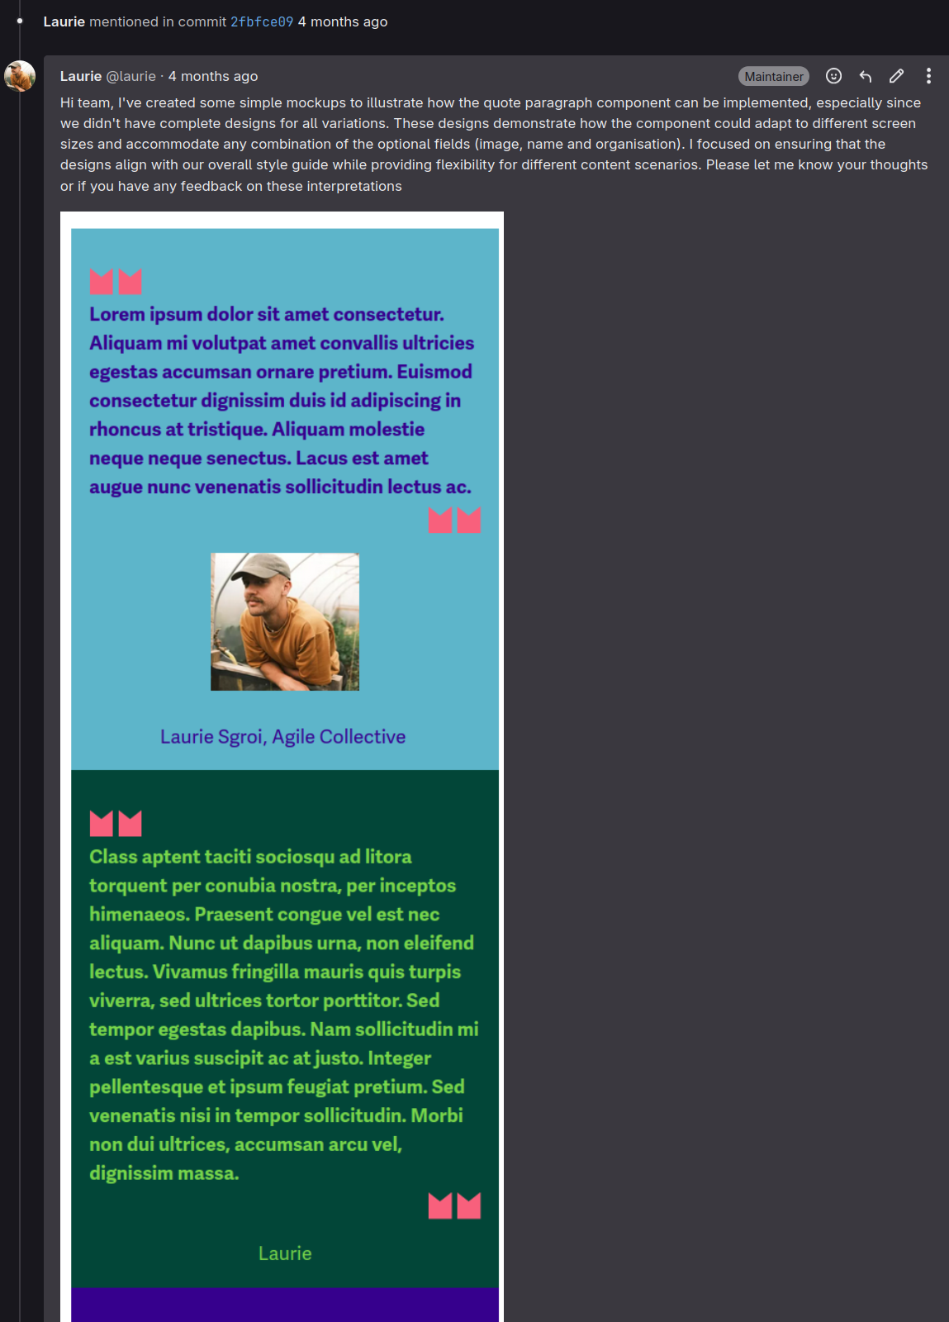
Figure 6 - Creating simple software designs to communicate with stakeholders

1.d.iv - Approach to Developing User Interfaces
My approach to UI development involved translating designs from Figma into responsive, accessible, and visually consistent web components. A notable challenge was handling components with optional fields not fully detailed in the design specifications. For these cases, I assessed the overall design and applied it to my implementations, ensuring that the UI remained cohesive.
I used conditional rendering techniques to incorporate these optional fields, see figure 7. For example, when the quote component needed to display an optional image or organisation name, I designed it so that these elements would only appear if data was provided. This approach maintained a clean, user-friendly interface regardless of which optional fields were included.
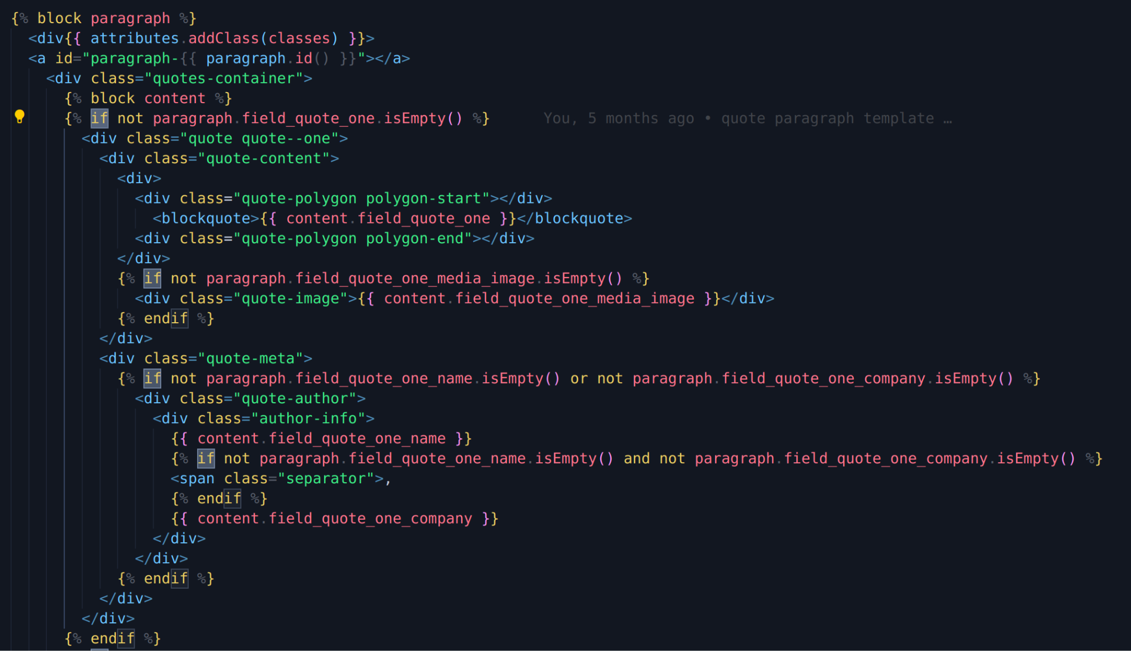
Figure 7 - Conditional rendering in the Quote paragraph template.

1.e - Testing and Quality Assurance
Testing was an essential part of ensuring that the Mental Health Foundation website met both the project’s technical requirements and the client’s expectations. Throughout each sprint, I conducted a combination of manual and automated tests to ensure the site performed as expected across various environments.
Acceptance criteria were defined for each task in GitLab, outlining the specific requirements and outcomes that needed to be met. Before moving any task to “Testing,” I reviewed these criteria to ensure that every feature had been implemented correctly. This was especially important for the more complex features, such as cross-browser compatibility and accessibility enhancements, which had to meet stringent requirements.
To verify cross-browser functionality, I used BrowserStack to run manual tests across a range of devices and browsers. This allowed me to identify any discrepancies in layout, performance, or functionality, ensuring a consistent user experience. I also conducted user acceptance testing (UAT) with the client, verifying that each feature worked as intended from the user’s perspective, see figure 8.
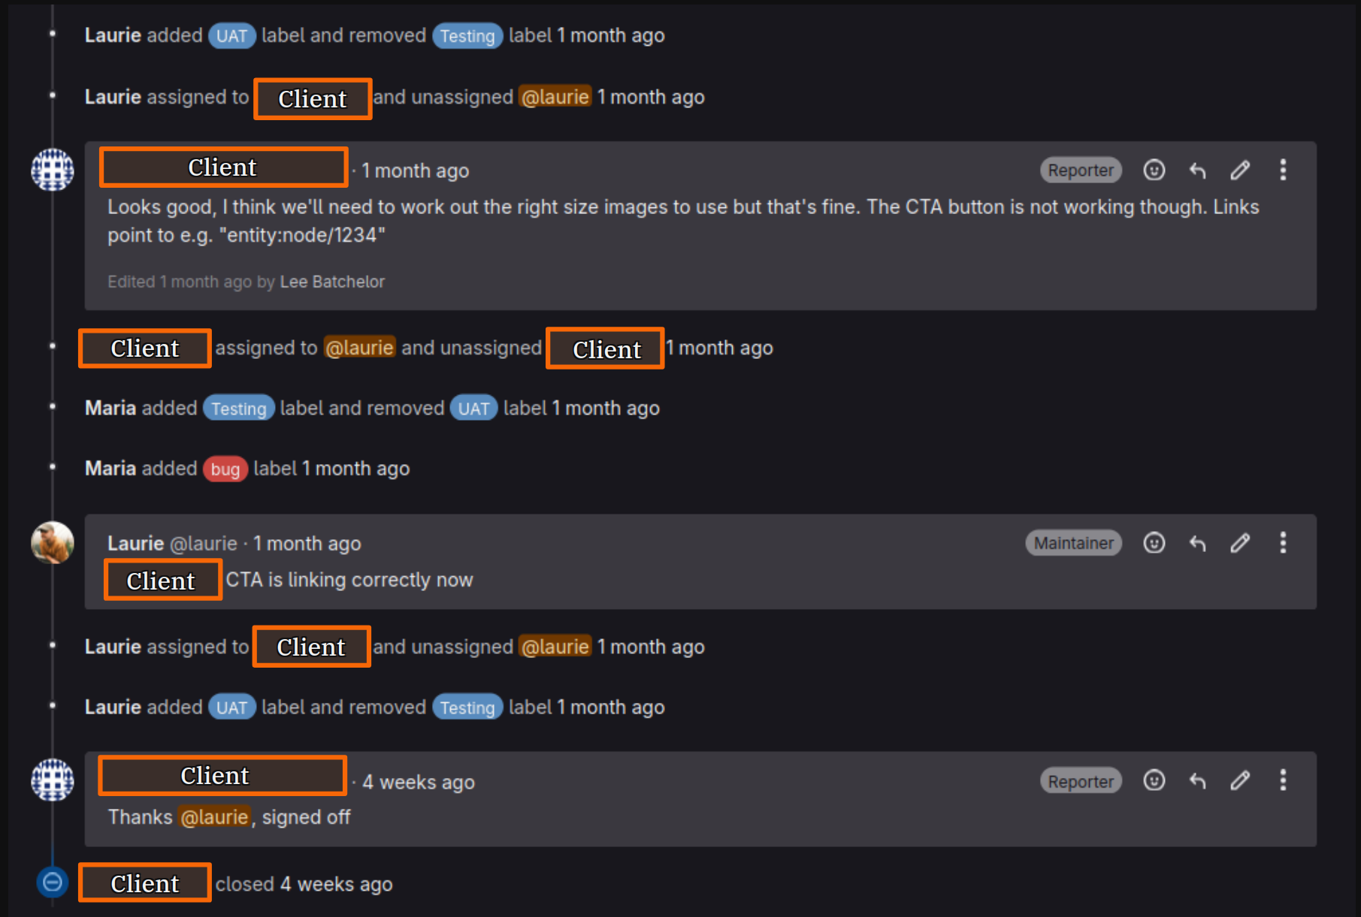
Figure 8 - Discussion on a ticket whilst UAT with the client.
The peer review process added an additional layer of quality control. Before code was merged into the development branch, another developer reviewed my work, checking for adherence to coding standards and ensuring the integrity of the implementation. After merging, the client conducted their own review to validate that the work met their expectations before deployment.
The combination of thorough testing, peer reviews, and client feedback ensured that we maintained high quality throughout the project, allowing us to catch issues early and adjust accordingly.

1.f - Release Management, Deployment, and Continuous Integration
Throughout the project, effective release management and deployment were critical to ensure the website's functionality and stability across environments. I adhered to a well-structured deployment process, combining version control and best practices that ensured consistency and traceability.

1.f.i - Version Control and Tagging
I used Git for version control, housed in a GitLab repository. To manage releases effectively, I followed Semantic Versioning, distinguishing between bug fixes, new features, and major changes to the codebase. Each release was tagged in Git to provide an identifiable snapshot of the code at various stages, which helped us roll back or reference specific releases when needed. This versioning and tagging approach ensured transparency, traceability, and easier collaboration across the team.

1.f.ii -Deployment Process
I deployed the project using Acquia, a Drupal-specific hosting platform. This system allowed us to manage and deploy code across three environments: development, staging, and production.
- Development Environment:
  - I worked locally, pushing completed features or fixes to the development branch. This ensured that new changes were isolated from the live environment, providing a safe space to conduct initial testing.
- Staging Environment:
  - Following successful local tests, code was deployed to the staging environment. Here, I conducted thorough testing for cross-browser compatibility, accessibility, and ensured the features met client acceptance criteria. Staging acted as a near-identical clone of production, allowing us to catch any potential issues before release.
- Production Environment:
  - After staging approval, the code was deployed to production. Acquia’s deployment tools ensured a smooth process with minimal downtime. Releases were scheduled to minimise impact on users, with rollback procedures in place to quickly address any critical post-release issues.

1.f.iii - Handling Unexpected Changes and Initiative
During the first major release, we encountered unexpected bugs after the production deployment. The complexity of debugging the issue was compounded by the fact that Acquia controlled the deployment pipeline and production environment, limiting my direct access to troubleshoot or deploy fixes.
While I didn’t have the access to resolve the issue directly in production, I took ownership of the situation within my remit. By working within the limits of the deployment process, I collaborated with the team to debug the issue locally and in staging. I quickly identified a solution, applied the necessary fixes, and then communicated effectively with a senior developer who had production access. They deployed the changes to resolve the issue, minimising further disruption to the live site.
This demonstrated my ability to handle unexpected challenges, act within my remit, and find a timely resolution by leveraging available resources and senior team members, ensuring the project stayed on track.

1.g - Security and Maintainability
Maintaining a high level of security and code maintainability was an essential requirement. As part of this, Drupal offers several built-in features and best practices that ensure sites remains secure and manageable over time.
- Built-in Drupal Security Features
Drupal comes equipped with security measures designed to protect user data and prevent vulnerabilities. For example, it sanitises data inputs automatically, reducing risks from SQL injection and cross-site scripting attacks. Drupal’s user permissions system also allows precise control over user access, ensuring that sensitive areas of the site are secure. I had access to an admin login, but when creating test content, I would use a content editor role to follow best practices around permissions—limiting access to only what’s necessary for the task helps keep the site secure.
- Code Maintainability Through Templates and Component-Based Design
The theme structure follows a component-based approach, with templates for each type of content. Using Drupal's templating engine, Twig, I created templates that handle the display of fields, layouts, and page structure, see figure 9. This setup not only makes it easier to update individual components but also keeps the code organised and scalable as the site grows. Clear, reusable templates make future adjustments to the design or functionality straightforward.

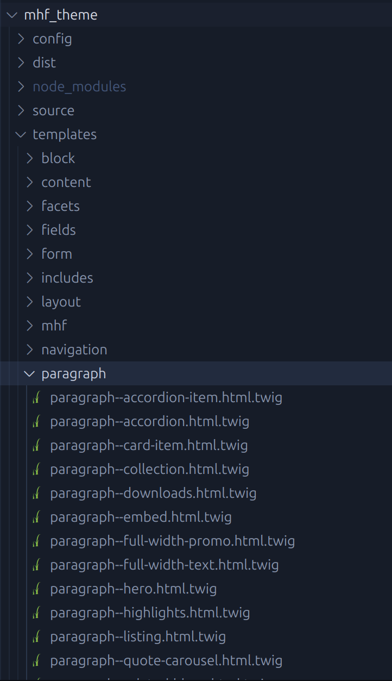
Figure 9 - Some of the many templates handling how content will be output.

- Regular Module and Core Security Updates
Keeping Drupal core and contributed modules up-to-date is crucial for security. I regularly checked Drupal’s update notifications and applied security patches when available. For example, in figure 10, I informed the client about a core update to patch known vulnerabilities and improve the system’s overall stability. This proactive approach ensures that the site remains secure and compliant with best practices.
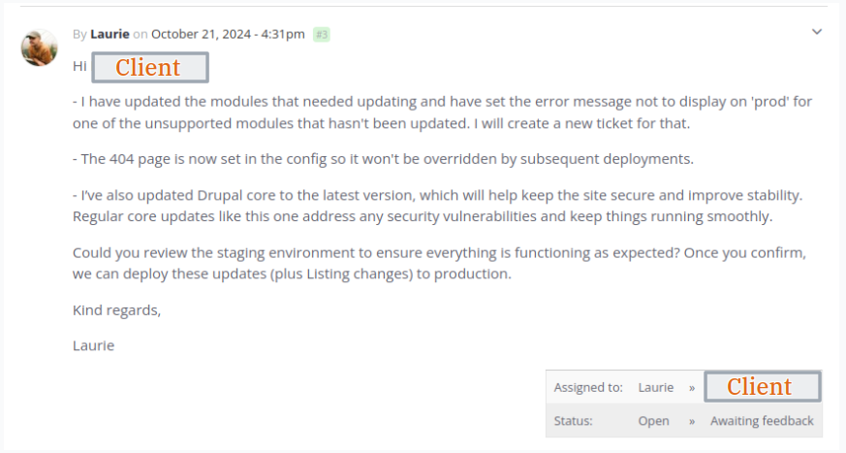
Figure 10 - A support ticket where I am informing the client that I have updated Drupal Core and modules.

2 - General Internal Activities

2.a - Sociocracy and Circle Involvement
At AC, we use sociocracy as our governance model, which encourages shared responsibility and decision-making by consent. This structure organises the team into various "circles" that oversee specific areas of the co-op. Each circle has a defined remit, allowing members to contribute based on their expertise and interests.
I am involved in multiple circles:
- Accessibility Circle: I contribute insights on accessibility, focusing on making our digital projects inclusive and actively exploring new standards and techniques.
- Social Circle: In this circle, I help organise events that foster team morale and well-being, supporting an inclusive, collaborative work environment.
- Tech Circle: Participating in this circle enables me to stay updated on industry best practices and emerging tools, helping me expand my technical expertise.
This involvement supports my continuous professional development by allowing me to engage in areas beyond project-specific work. Membership of a circle is voluntary and we may be members of as few or as many as we like. This reflects my curiosity to adapt to the business context and provides valuable learning opportunities across the company.

2.b - Drupal Development
To grow as a developer within a Drupal-focused agency I have taken on a proactive approach to learning Drupal in-depth. This includes:
- Mentorship: I’ve organised weekly shadowing sessions with an experienced developer to deepen my understanding of Drupal. Together, we've focused on learning Single Directory Components (SDC)—a recently integrated Drupal core module that simplifies component-based theming and is likely to shape the future of Drupal development. Working through SDC has given me hands-on experience with this module's capabilities and best practices for implementing modular design within Drupal, enhancing my skills and aligning with current trends in Drupal theming..
- PHP Skills: Recognising the importance of backend skills for full-stack development, I have dedicated time to learning PHP. Expanding my PHP knowledge allows me to handle tickets that go beyond front-end work, enabling me to contribute more broadly to the team and respond to a wider range of project needs within the business.

2.c - Accessibility Development
Accessibility is a central focus in my development, both in project work and as part of my professional growth. My activities include:
- Accessibility Circle: As a member of the Accessibility Circle, I collaborate with colleagues across various roles, I help track, manage and conduct accessibility audits for client projects, creating issues for our team to address as part of ongoing support work. We also focus on improving accessibility internally, ensuring the tools we use and our workflows foster an environment where accessibility is a priority and everyone is engaged in maintaining high standards.
- Monthly A11y Drop-ins: I attend and facilitate monthly drop-ins with the accessibility community to stay updated on best practices and new resources.
- Web Accessibility Certification: I am pursuing a web accessibility course with the goal of becoming a certified accessibility developer, a step that strengthens my commitment to inclusive web practices, see figure 11.
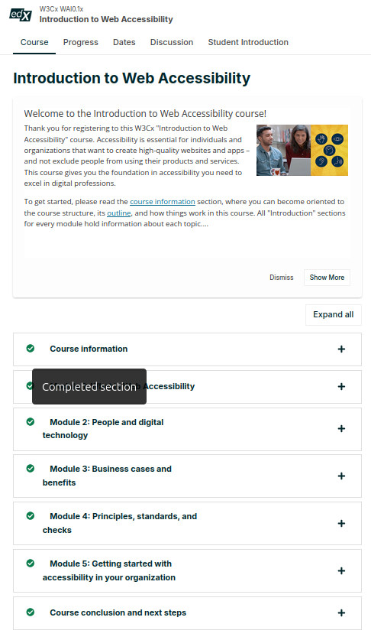
Figure 11 - Screenshot of my progress on the W3Cx Introduction to accessibility course

These activities help me build my technical and interpersonal skills, supporting my growth as a developer and my ability to contribute effectively to AC’s values and the work we do.

3 - Agile.coop migration

3.a - Project Overview
This was my first project at AC, working on an internal migration of our agile.coop site from Gridsome to Eleventy. The aim was to improve site performance and maintainability while keeping the design and functionality consistent with the original.

3.b - Roles and Responsibilities
The project team included:
- Project Manager: Coordinated planning, scheduling, and resource allocation and served as the main point of contact for stakeholders.
- Developers: Myself and one other developer carried out the core development tasks, addressing each migration task and conducting testing to ensure a seamless transition.
- Product Owner: Represented the business perspective, setting priorities and ensuring alignment with AC's objectives.
- Technical Consultants: Two experienced engineers supported us with technical advice and guidance on best practices.
- Designers: Although no UI/UX work was needed upfront due to the focus on replication, we consulted our design team later in the project to resolve an issue related to a blog filter component

3.c - Software Development Lifecycle
The migration of agile.coop from Gridsome to Eleventy followed a structured Software Development Lifecycle (SDLC), covering the essential phases:
- Plan: This phase involved scheduling, estimating resources, and gathering requirements from stakeholders. Since this was my first project, much of the planning was already in place before I joined, so I was able to work within a clear, predefined roadmap.
- Design: A major reason for this project was to test Eleventy’s capabilities and use it as a case study for our 11ty - Drupal starter kit. Since the starter kit integrates both Eleventy and Drupal, these technologies were predetermined as our core technical requirements. This decision influenced not only our design choices but also how we structured data flows and templating to make the most of Eleventy’s static site generation features, while relying on Drupal’s content management capabilities. The project allowed us to experiment with design patterns that highlight Eleventy’s efficiency in rendering and Drupal’s strengths in managing complex data.
- Development: We maintained a backlog of issues on GitLab using the GitLab issue kanban board and worked through them systematically, tackling tasks one at a time until everything was completed. This approach ensured we stayed organised and addressed each requirement in turn.
- Test: Testing was a mix of manual and automated processes, and it ran in parallel with development. We tested code as it was written to catch issues early and ensure quality at every stage.
- Deploy: After testing, completed tasks were deployed to a development environment. Because this migration involved a major shift in our static site generator, we couldn’t incrementally update the live site, so production deployment waited until all tickets were completed.
- Maintain: After launch, I monitored performance and accessibility through our benchmarking tool, fixing any bugs that the client raised through our support system and ensuring standards were maintained.
This lifecycle ensured a smooth, organised migration to Eleventy, meeting both our technical and project goals.

3.d - Software Development Methodology
We used the Agile methodology for this project, which aligns with AC’s standard approach. Agile emphasises iteration, collaboration, and adapting to feedback, making it well-suited for projects where requirements might change or where regular input from team members is essential. In this case, using Agile was also intended to help me gain experience with AC’s preferred workflow for project processes.
Given that this project had a clearly defined scope, the Waterfall model—where each phase (planning, design, development, etc.) is completed sequentially—could also have worked. Waterfall is effective when project requirements are stable and unlikely to change, as it minimises iterative changes and allows a straightforward progression through each phase. However, our goal was to help me get familiar with Agile practices, so Agile was the chosen approach.
Another alternative is the Spiral model, which combines iterative cycles with a structured, sequential flow similar to Waterfall, while prioritising risk analysis. The Spiral model is beneficial for large, complex projects with higher risk levels, as it builds in regular opportunities for evaluation and improvement by creating prototypes at each stage. However, it tends to be more resource-intensive and costly, making it less suitable for smaller projects like ours with a limited scope.

3.e - Organisational Policies and Procedures
Organisational policies and procedures are essential to managing code changes and maintaining the integrity of live environments. For this project, AC’s policies on continuous integration (CI) and version control were key.
Our production site had continuous integration set up, see figure 12, so it was crucial to follow proper version control practices. We worked locally and used the organisation's GitLab repository to manage our code. Changes were made on local branches and pushed to the development site for testing. Before merging any changes, we ensured that code was fully reviewed and tested. The CI process helped maintain code quality and ensured that only stable, tested features made it into the main branch.
In addition to our version control practices, I developed a library of automated tests for the site that was incorporated into the CI pipeline. This library acted as a barrier against bugs: if the tests failed, the site would not redeploy. This ensured that any issues within the scope of my tests could be identified and resolved before changes were pushed live.
Given the decoupled nature of the project, we worked across multiple environments—development, staging, and production. We had a few specific branches for the process:
- master: The old Gridsome site.
- stage: The staging branch used for final testing before deployment.
- develop: The main working branch where all development took place.
- 11ty-main: The branch where we built and worked on the new Eleventy site. This branch was merged into a new main branch at the end of the project to replace the old master branch.
We used SSH access to the servers to manually rebuild the site, make configuration changes to the Drupal backends, clear the cache, and perform other administrative tasks. However, before making changes to any deployed sites, I always checked the branch that was currently deployed. If it wasn’t the expected branch (11ty-main, develop, or stage), I’d check with the last person to ensure I wasn’t interrupting someone else’s work.
The production site wasn’t redeployed until the very end of the project, when all features had been finalised and thoroughly tested. This approach ensured that no interruptions occurred on the live site, and changes were introduced smoothly.
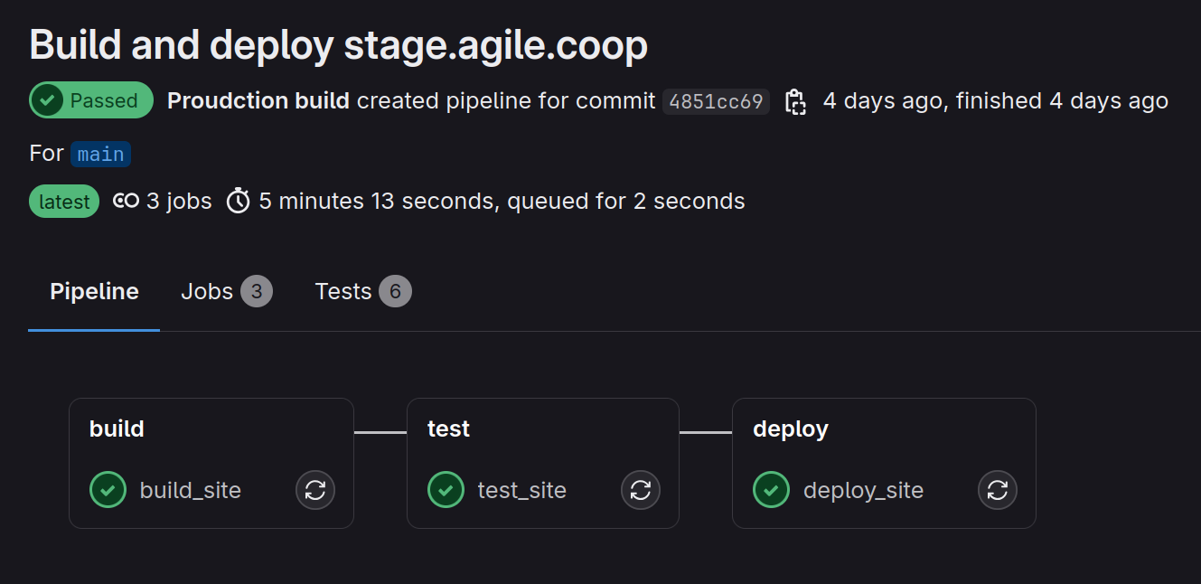
Figure 12 - Screenshot of the CI pipeline in place on agile.coop

3.f - Unexpected Challenges
One challenge we faced was that the blog filter from the original Gridsome site wasn’t compatible with Eleventy, which required us to choose a different component. This change affected the design and functionality, so we reached out to the designers for approval, ensuring the solution fit our original vision. By proactively addressing this with the design team, we kept the project on track while making sure the adjustment met the site’s aesthetic and functional standards.

3.g - Testing

Ensuring the reliability and performance of the new site was important. To achieve this I conducted an evaluation of software testing frameworks and methodologies. End-to-end (E2E) testing emerged as the most suitable functional approach, leading to the selection of Cypress as the testing framework of choice. The decision was driven by the need for comprehensive testing that mirrored real-world user interactions. Given the existence of a live production site, Cypress allowed for direct comparisons and validations, offering insights that unit testing alone could not. While unit tests were considered for verifying the functionality of individual components, it was determined that they would not yield as much value in the time I had available as E2E testing with Cypress would. This choice reflects a commitment to quality and efficiency, prioritising tests that provide the most significant impact on user experience and reliability.

3.g.i -Application of Testing Types and Frameworks
The project's testing strategy encompassed various test types to ensure thorough validation of the system, below I discuss testing that I conducted and would like to conduct going forwards:
- Integration Testing: By simulating the interactions between different components of the site, I verified that combined parts operated well together. Cypress facilitated these tests by allowing me to mimic user actions that involved multiple system components.
- System Testing: The entire application underwent testing as a whole. The tests I wrote in Cypress played a crucial role, replicating end-user scenarios to validate the system's functionality.
- Non-Functional and Performance Testing: Utilising Lighthouse reports, I assessed and compared the performance and accessibility of the development site against the production site. This approach allowed for targeted improvements, enhancing the overall user experience. Through this testing I found that the splash cover greatly affects largest contentful paint (LCP), a core web vital. I changed the way the splash rendered which improved LCP and the overall performance of the site, see figures 13 and 14.
- User Acceptance Testing (UAT): I didn’t conduct UAT as I decided this wouldn’t have been a valuable use of time as the user experience of the site wasn’t changing, but it would ensure the application met user expectations and requirements.
- Crossbrowser Testing: I used BrowserStack for cross-browser testing, ensuring compatibility and optimal performance across different devices and platforms.
- Quality Assurance Testing: Quality assurance was maintained by clearly defined issues, detailed acceptance criteria, and a definition of done to guide each task to completion, see figure 15.

3.g.ii - Security Testing
To ensure the new site’s security, I conducted a dependency review to identify any vulnerabilities within third-party libraries. Regular checks of dependencies helped maintain a secure codebase, with updates applied as needed to address potential risks.
Additionally, I evaluated the Content Security Policy (CSP) headers implemented on the site. The CSP is configured to block all content by default (default-src 'none'), with specific permissions granted only for essential resources, including Google Analytics and limited external services. The policy also includes allowances for internal scripts and inline styles where necessary, balancing security with functional requirements.
By maintaining a strict CSP and monitoring dependencies, I helped to ensure that the static site remained resilient against common security threats while preserving core functionality and performance.

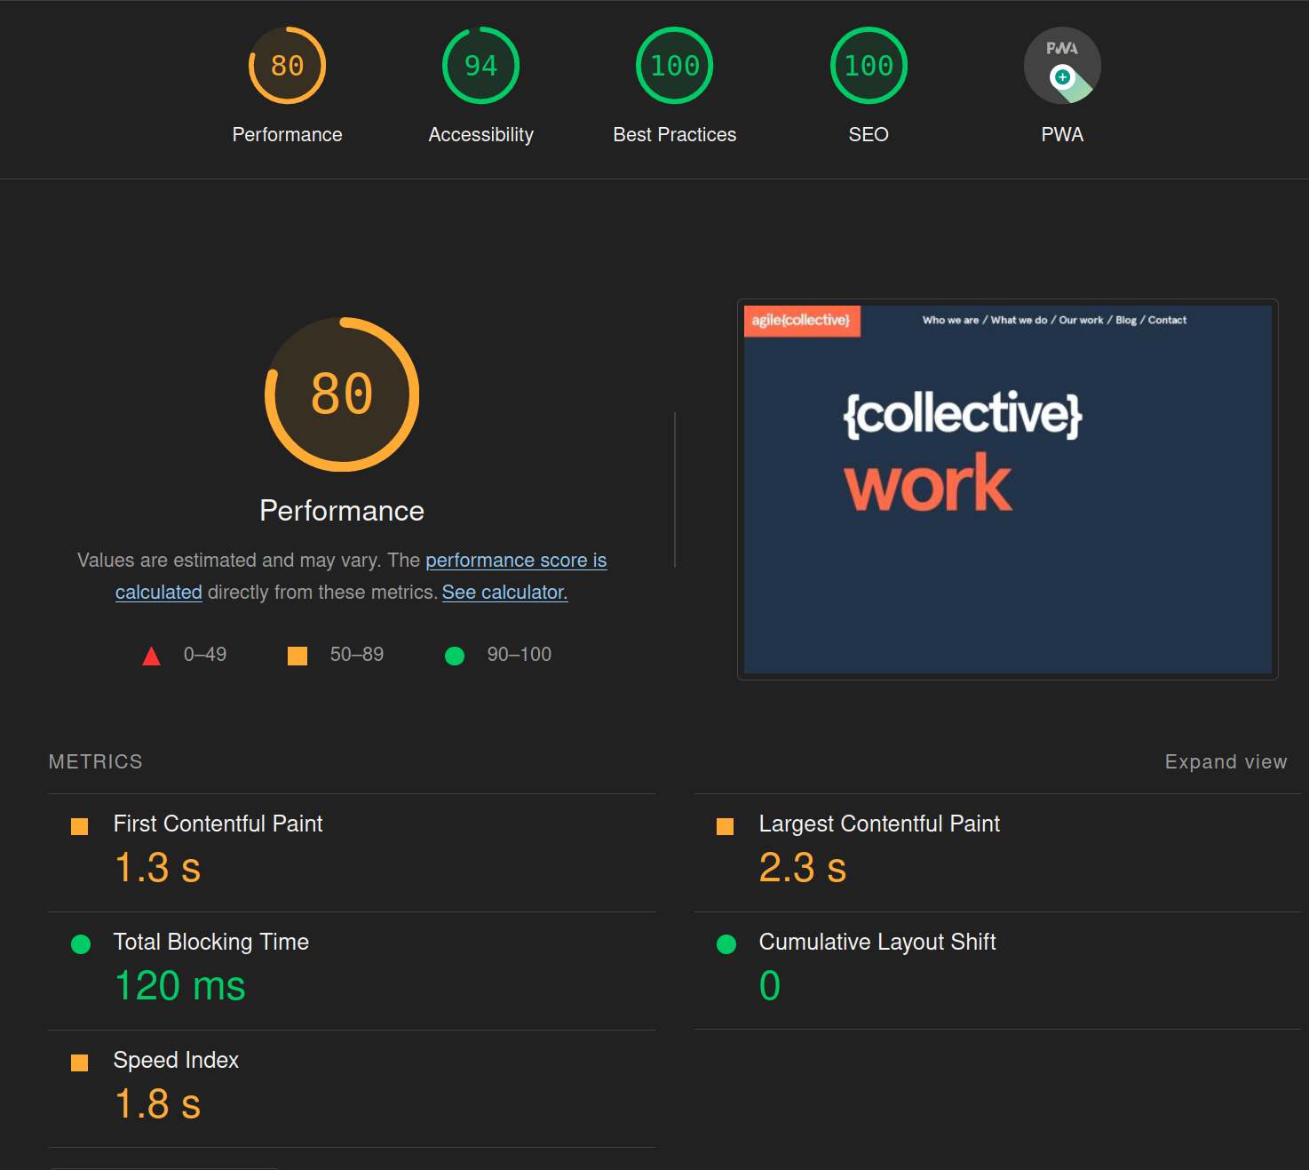
Figure 13 - Lighthouse test showing the splash bringing the performance score down.
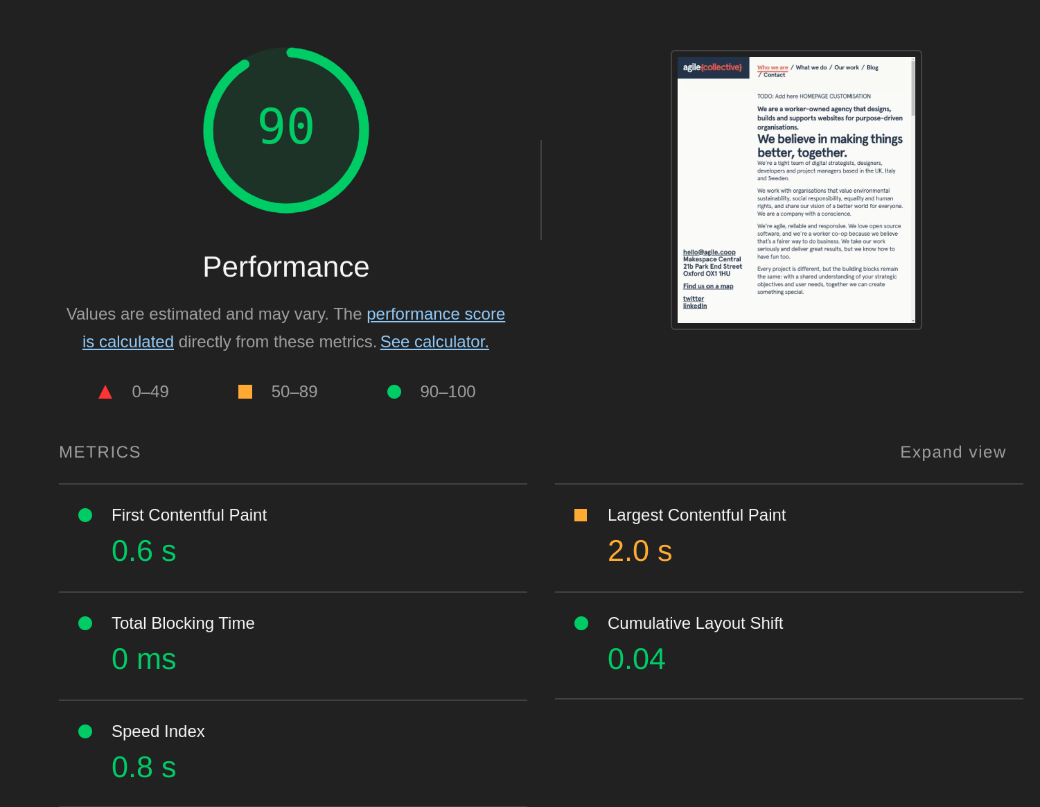
Figure 14 - Lighthouse tests showing increased performance after changing how the splash displays
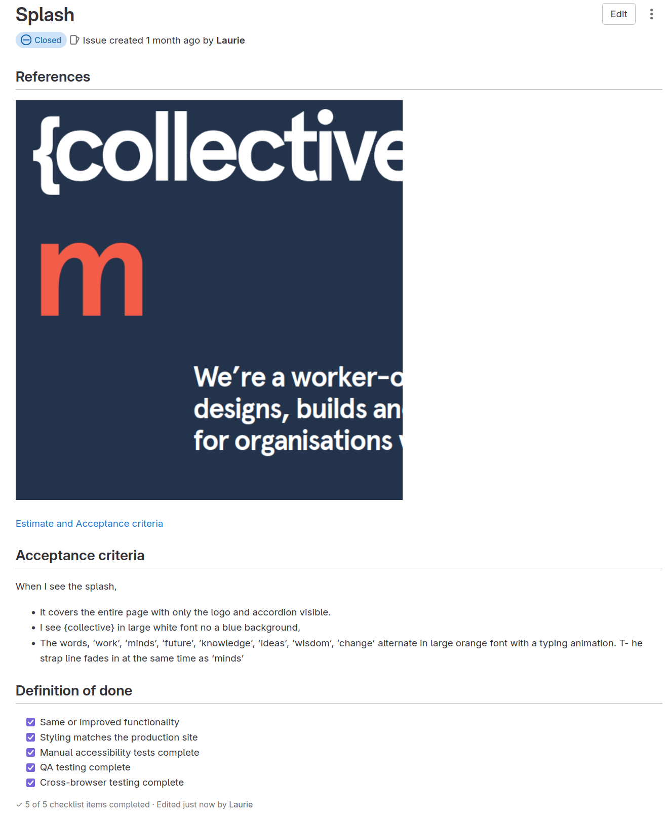
Figure 15 - A ticket from gitlab, showing acceptance criteria and definition of done.

3.h - Tech Talk
After the project, I delivered a Tech Talk during a company-wide meeting, where team members present new or interesting technologies and projects they've been working on, see figure 16. During my presentation, I created a flowchart in Miro to explain how Eleventy interacted with the Drupal backend, see figure 17, providing a clear visual representation of the mechanics of the new site. This approach allowed me to effectively communicate complex technical details to both technical and non-technical team members, ensuring everyone had a solid understanding of the project. By using simple, visual tools, I was able to communicate complex technical concepts in an accessible way.
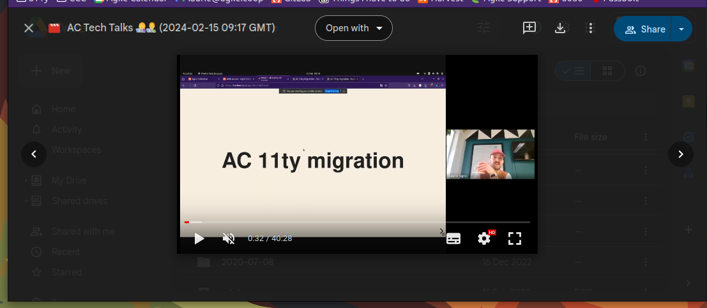
Figure 16 - Screenshot from the Tech Talk I have on the agile.coop migration

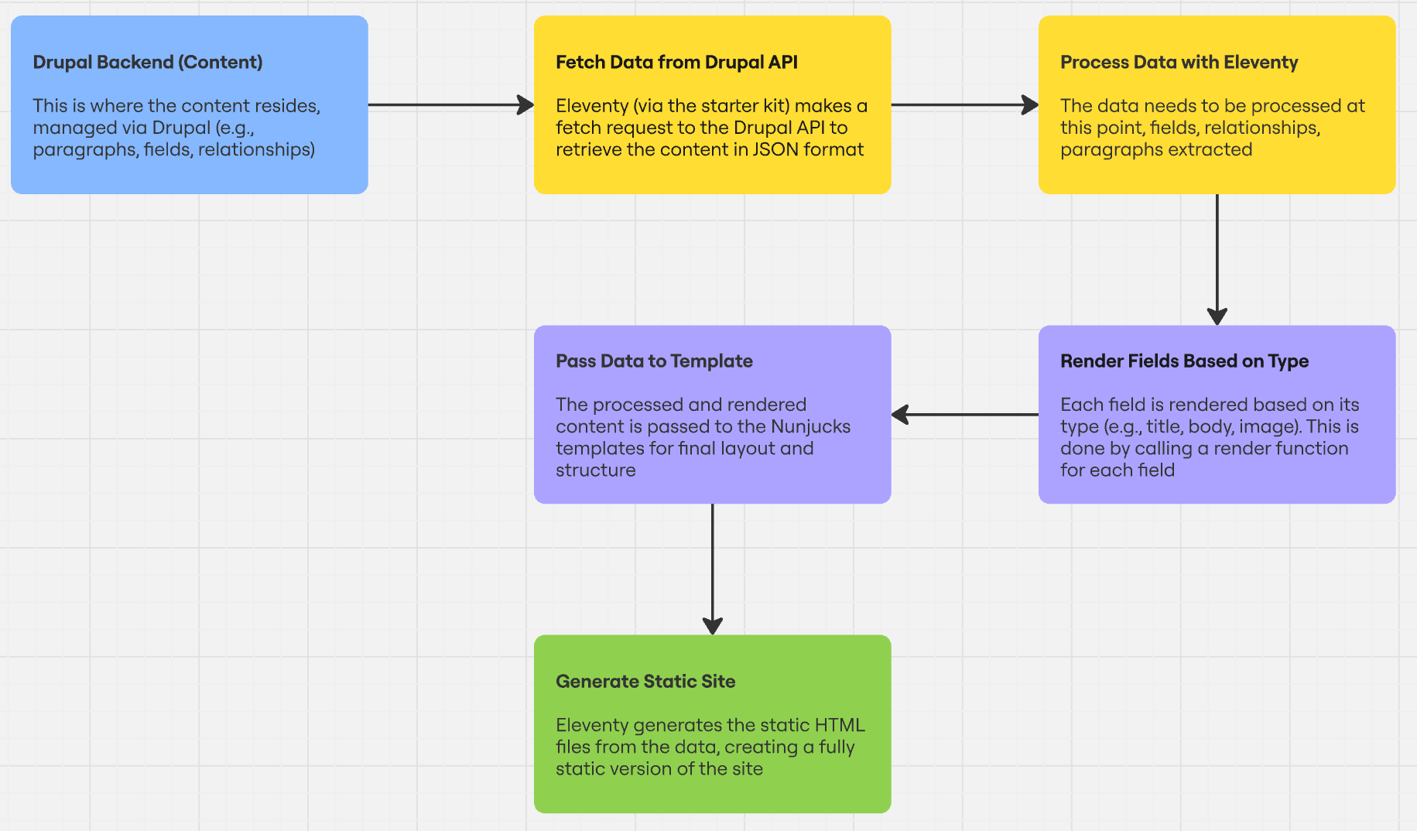
Figure 17 - Flowchart used to communicate understanding of the programme

4 - BISA Accessibility user testing
We conducted accessibility user testing for our client, BISA, to evaluate the site's usability for users with diverse accessibility needs.

4.a - Test Setup and Methodology
- Testing Framework: Followed a structured methodology for user testing, which involved engaging users with various assistive technologies—such as text-to-speech software, voice activation, and keyboard-only navigation.
- Participant Interaction: Each user was asked to complete specific tasks, such as locating information and navigating the site, while providing real-time feedback on their experiences.
- Note-Taking Role: As the note-taker, I documented user comments and interactions, see figure 18. I observed and noted nuances in their behaviour and interaction with the site, recognising aspects that might not have been verbally communicated but significantly impacted their user experience.
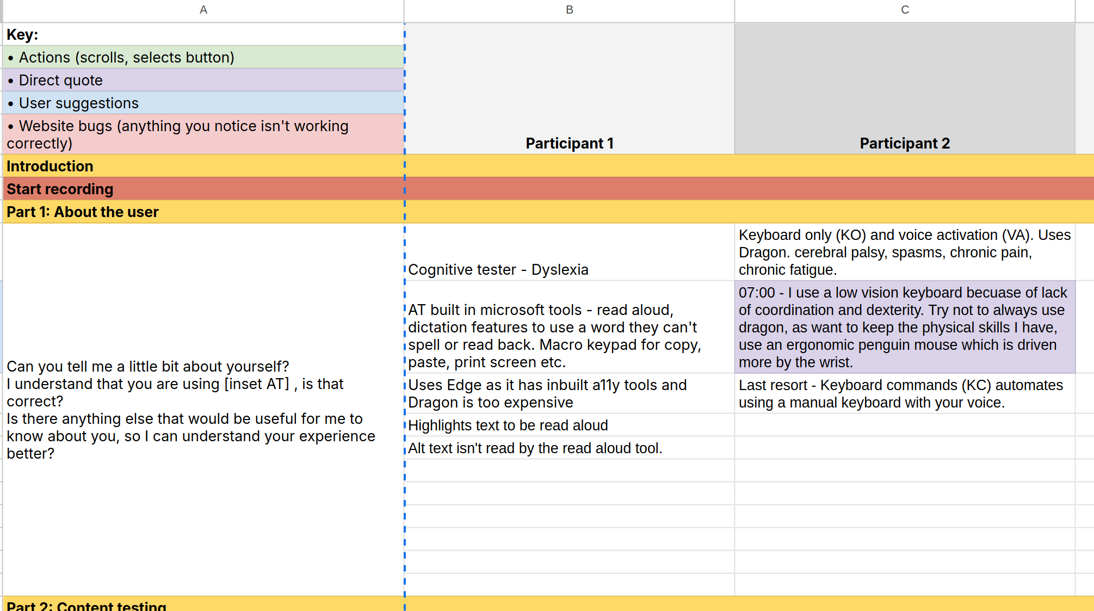

Figure 18 - Screenshot of the document used to record and notetake during user testing

4.b - Key Learning Outcomes
- Conducting User Testing:
  - Gained practical experience in user acceptance testing by evaluating how effectively the website met the needs of users with disabilities.
  - Documented findings and user feedback to identify areas for improvement, demonstrating adherence to established testing methodologies.
- Collaboration and Inclusion:
  - Collaborated with colleagues from different roles to design and execute the testing process, fostering a positive attitude toward inclusion and diversity.
  - Valued user perspectives and incorporated their feedback, highlighting the importance of diverse experiences in the design process.

5 - Cyber Essentials
At AC, we prioritise the protection of personal data, safety, and security in compliance with ethical, legal, and regulatory standards. Our co-op has obtained Cyber Essentials accreditation, which helps protect against common cyber threats and as such we have a comprehensive data privacy and security section in our staff handbook, see figure 19. I reached out and engaged with the person responsible for our application, discussing the implications of the accreditation and the specific security measures we have implemented.
As a member of the Technical Circle it is my responsibility to familiarise myself with these new policies, as seen in the minutes from our Circle meeting after we enacted them, see figure 20.
I’ve also aligned my own device setup with our Device Security Policy, which requires full disk encryption, regular OS updates, and the use of trusted software repositories. Recently, I upgraded my system from Ubuntu 22.04 to Ubuntu 24.04 LTS, ensuring my device remains compliant with the company's policy regarding operating system updates, see figure 21. I follow additional security protocols, including the use of LUKS encryption and UFW for firewall management, as outlined in the policy.
Through this process, I have deepened my understanding of the steps needed to ensure data protection and device security, reinforcing our commitment to best practices in safeguarding sensitive information.
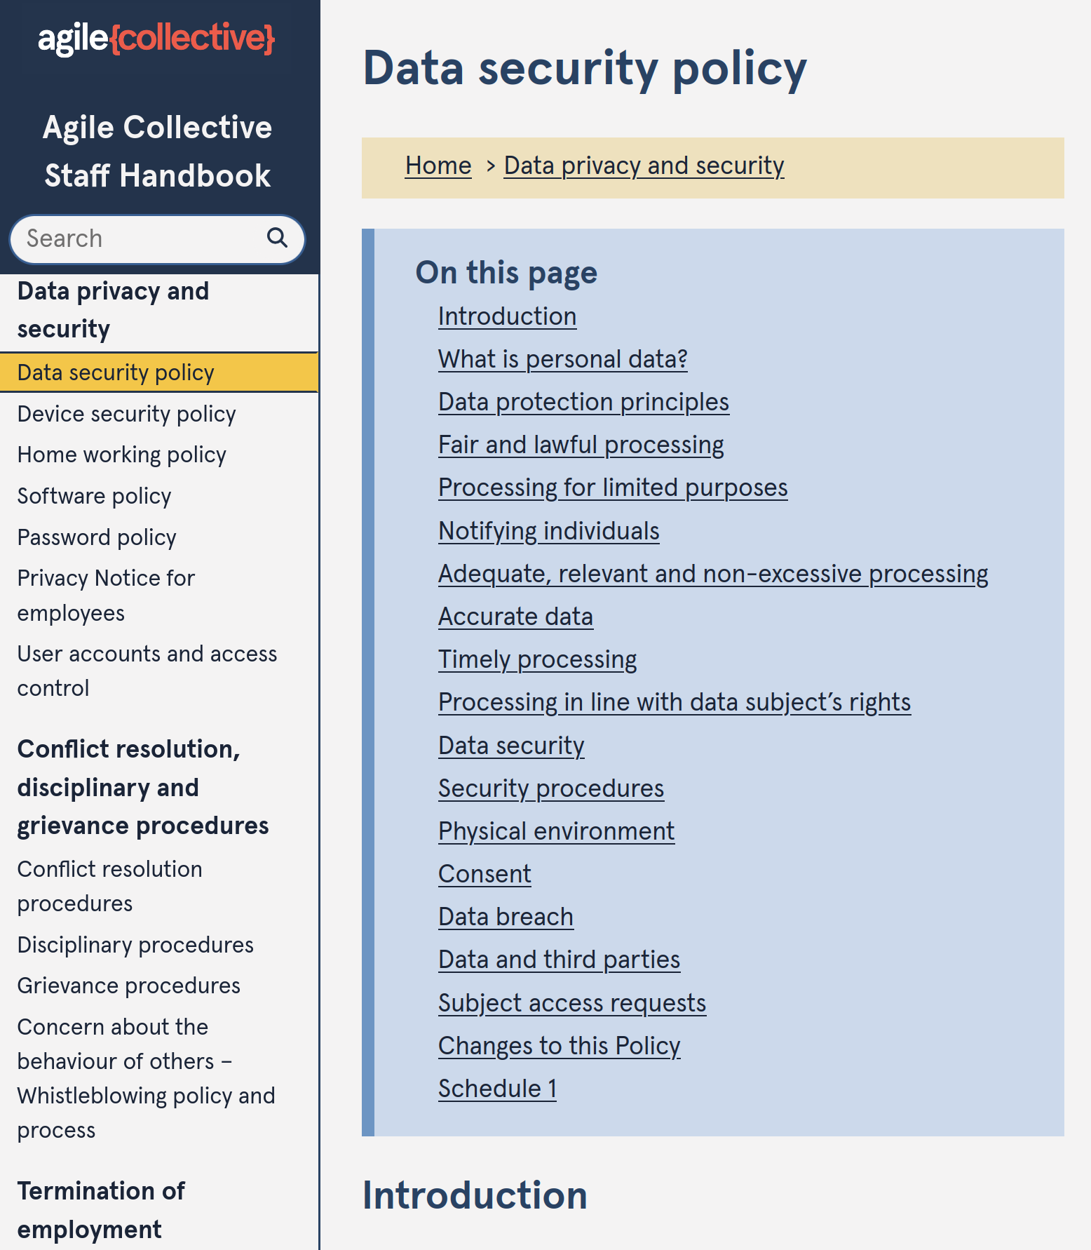
Figure 19 - Screenshot of the Data Security section of our handbook which came from the Cyber Essentials accreditation.
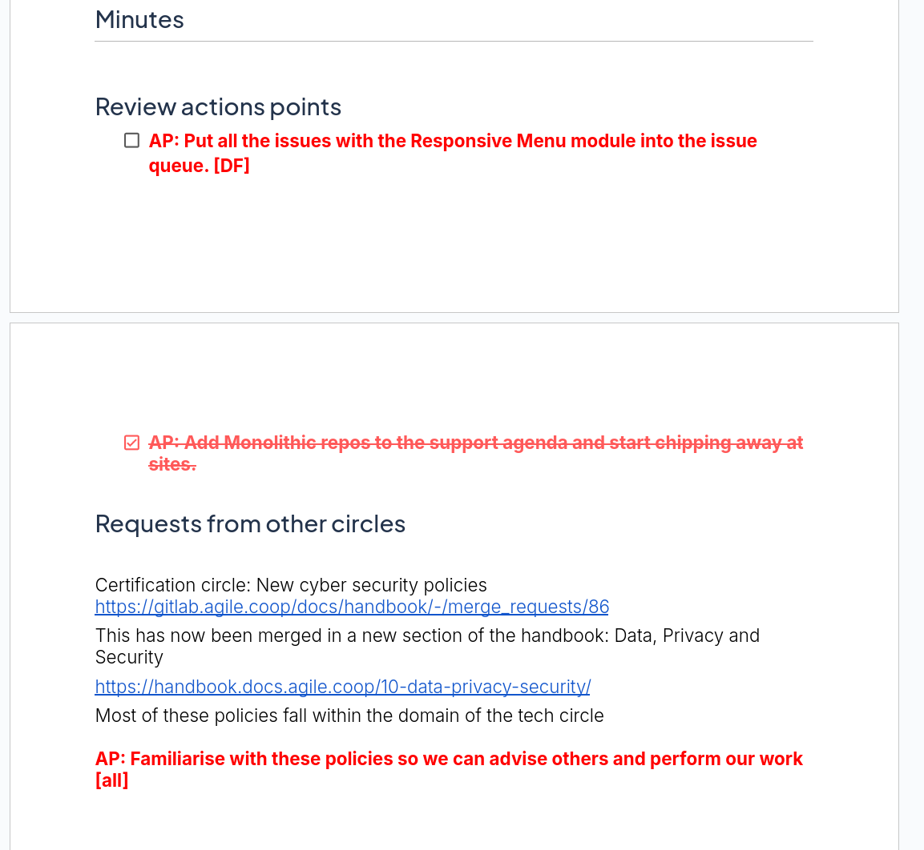
Figure 20 - Screenshot of Technical Circle meeting minutes regarding Cyber Essentials
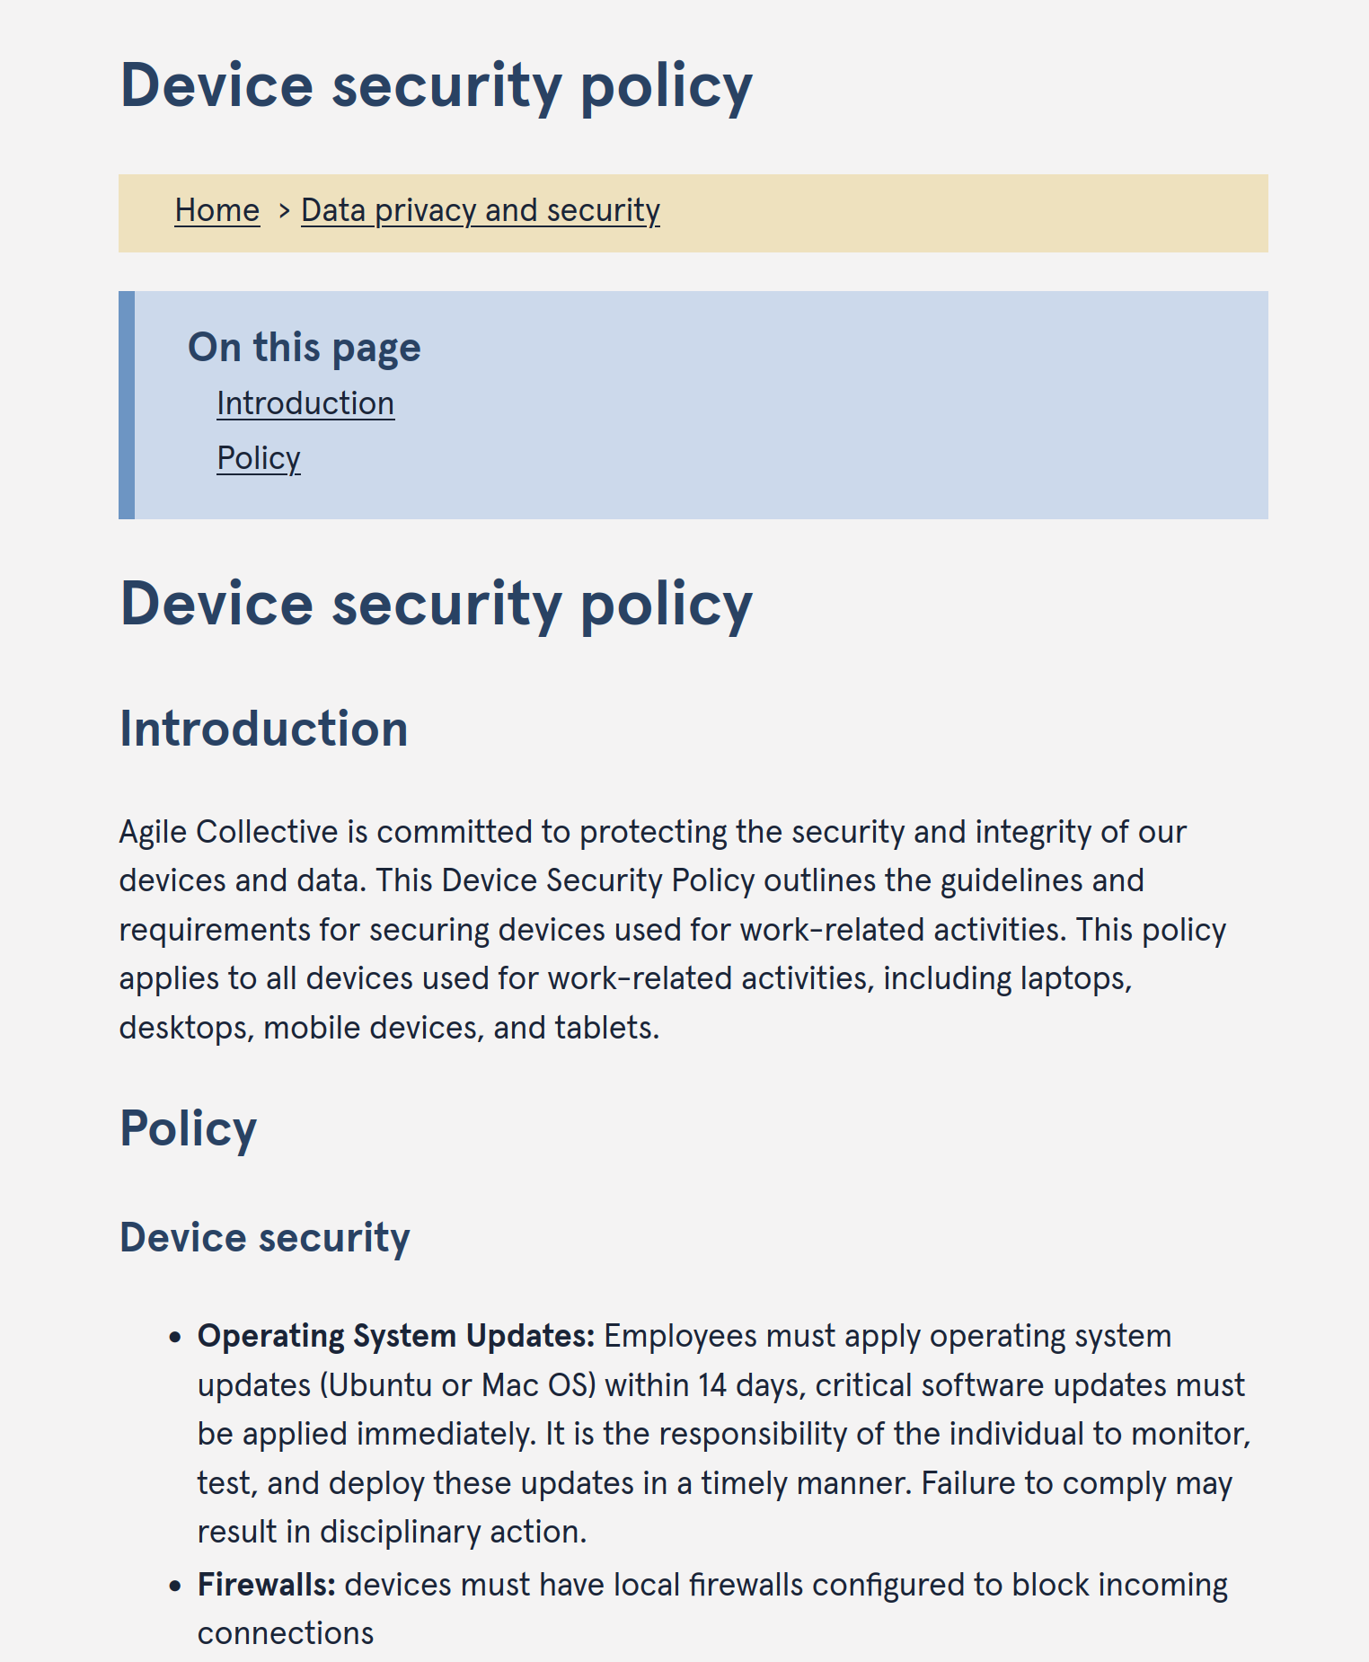
Figure 21- Screenshot of the device security policy section of the staff handbook

6 - 11ty - Drupal Starterkit

6.a - Introduction
The project aimed to create a bare-bones starter kit to build sites with a decoupled Eleventy front end and a Drupal back end. The goal was to generalise the process of building such sites. The agile.coop site was built with the starter kit in mind, with the intention to strip away code unique to our site and provide a simplified, reusable framework for anyone to use. The starter kit is intended to be released as an open-source project, allowing developers to quickly create a decoupled Eleventy-Drupal site with minimal setup.

6.b - Project Collaboration
We worked on the project asynchronously as an internal initiative. A group of interested parties was set up to discuss issues and tasks, and we met weekly to discuss progress and address any challenges. This approach ensured continuous communication and collaboration among team members, even though we were not always working simultaneously.

6.c - Simplifying the Setup Process
I wanted to simplify the setup process to make it more accessible to new users. To address this, I developed the buildEleventyConfig.js script, see figure 22, which automates the configuration process by fetching content types from a specified Drupal site and generating a configuration document . This script allows new users to quickly set up a basic site, reducing the need for repetitive code. I worked independently on this solution, demonstrating initiative and problem solving skills.
To ensure the best approach for the setup process, I evaluated different software design approaches:
- Manual Configuration: Initially, we considered a manual approach where users would need to write the configuration themselves. This method was deemed inefficient as it required repetitive work and increased the likelihood of user errors.
- Automated Script: I proposed an automated script to handle configuration. This approach was preferred because it minimises manual work and reduces errors whilst making the starter kit accessible to users without technical knowledge. By fetching content types dynamically, the script ensures consistency in the setup process.
I recommended the automated script approach as it provided a reusable solution to a common problem faced by developers setting up decoupled sites. I communicated this to the team and demonstrated my proposed solution in a group meeting. This recommendation was based on the need for efficiency and reducing manual repetitive tasks, which aligns with the principles of effective software design.

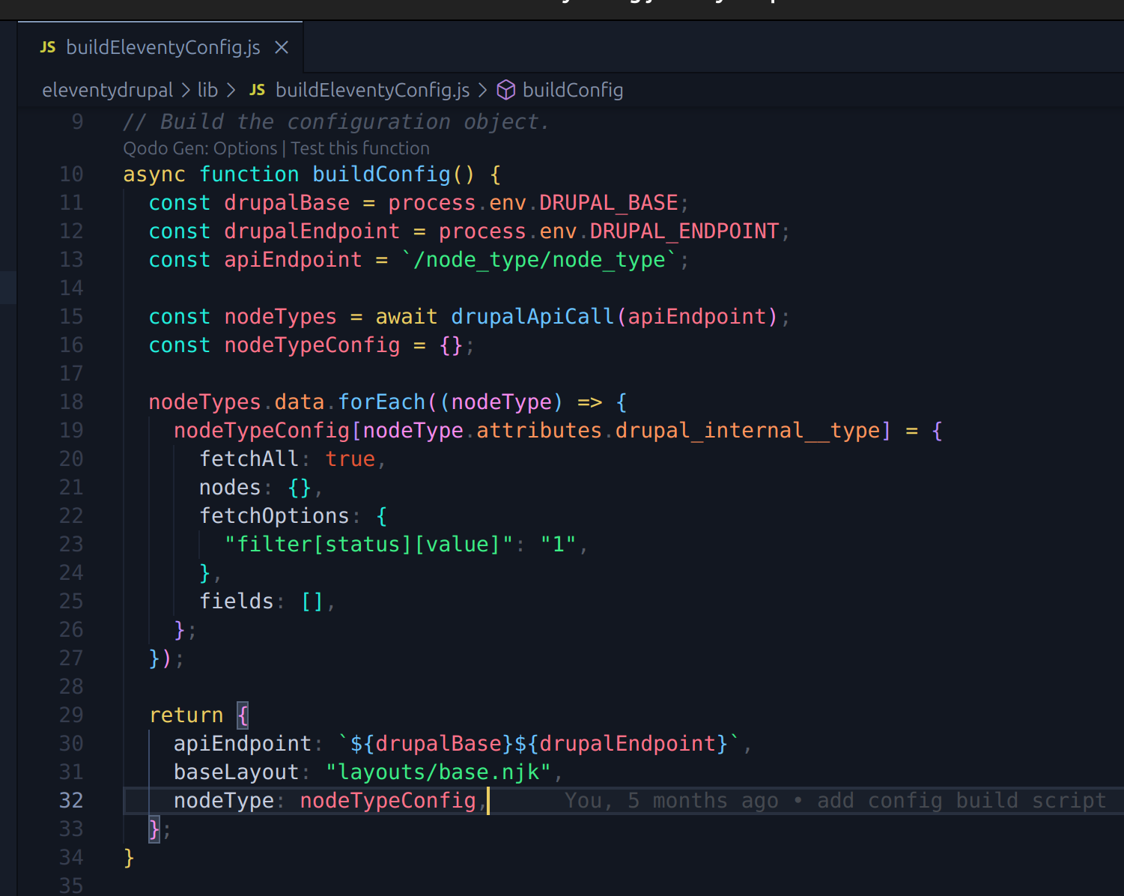
Figure 22 - A JavaScript function which builds and returns a configuration object for fetching and organising Drupal node types.

6.d - Authentication for API Calls
To support data protection in the starter kit, I implemented OAuth2 authentication for API calls, see figure 23. This allows users to restrict access to sensitive data, ensuring only authenticated requests retrieve protected fields. This approach helps maintain both security and ease of use, aligning with best practices in secure, decoupled site architecture.
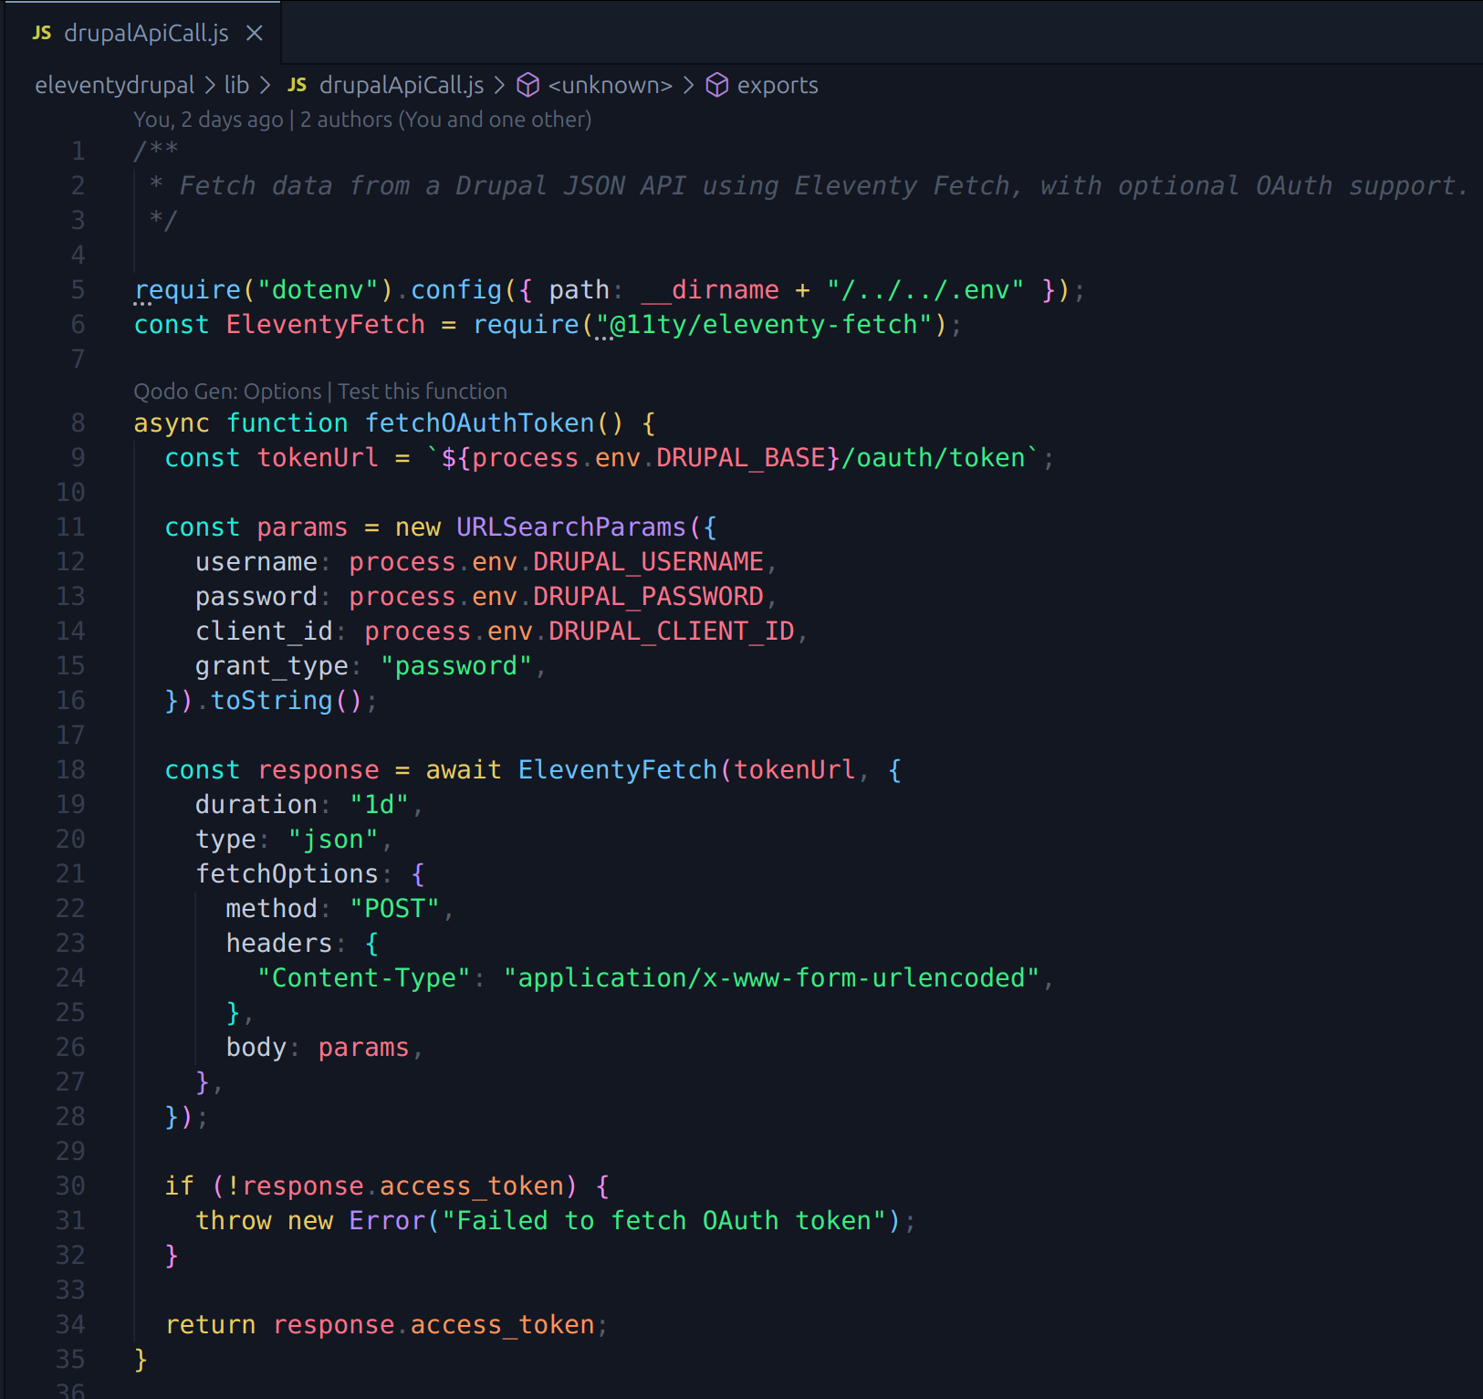
Figure 23 - Code snippet showing the fetching of an authentication token.

6.e - Linking Code to Data Sets
The drupalApiCall.js script, see figures 23 and 24, links our code to the Drupal dataset by making an API call to fetch content from the Drupal backend. It constructs the API URL using base and endpoint details, adds optional parameters, and fetches the data using EleventyFetch. If authentication is required, the script adds an OAuth token to the request headers. The data is returned as JSON and cached for one day to ensure efficiency. This simple setup connects our code directly to the Drupal data.

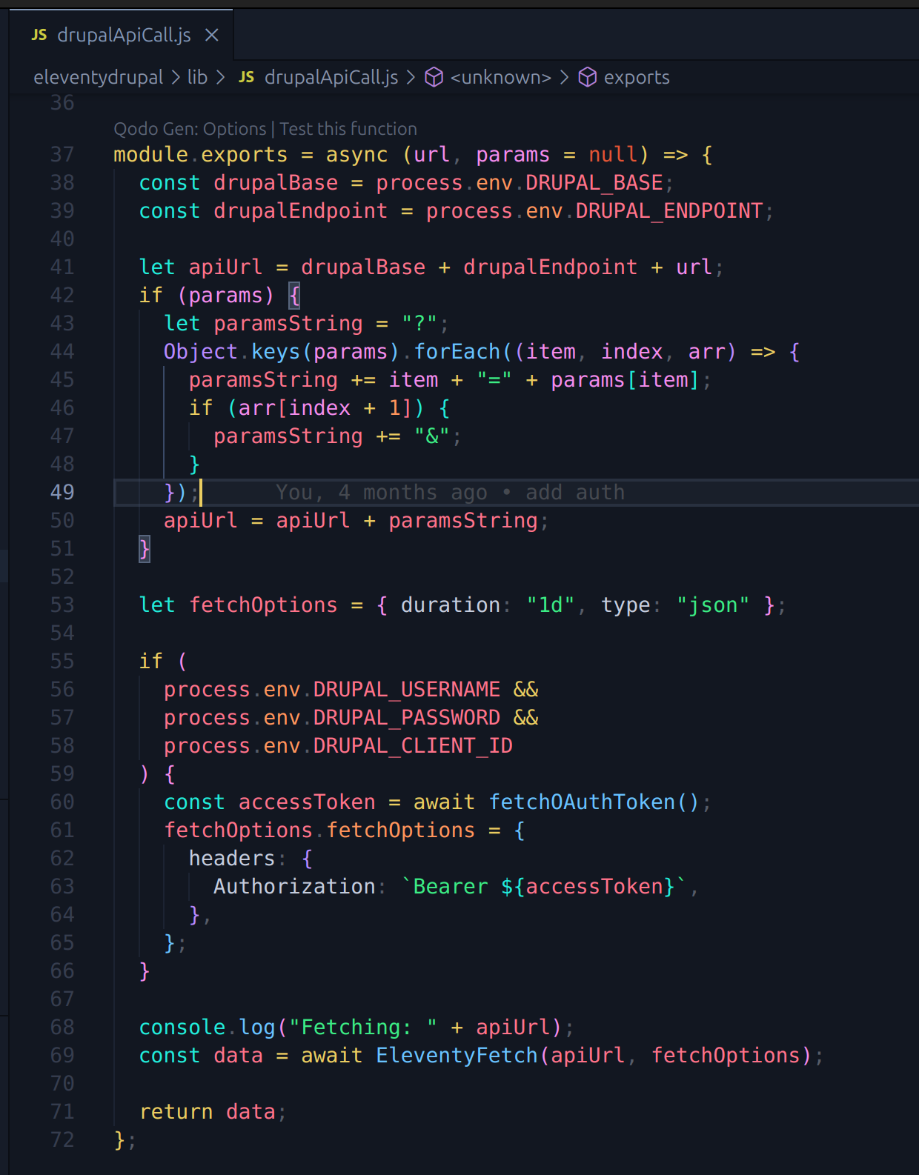
Figure 24 - Code snippet showing drupalApiCall.js for linking code to the dataset.

6.f - Mentoring
I served as a mentor for a team member on work experience, guiding them through the project requirements and assisting with development tasks, see figure 25. Throughout the project, I tailored my communication approach to match the team member's level of technical knowledge, focusing on accessible language and breaking down complex concepts. For example, when explaining the more technical Drupal configuration setup, I simplified technical terms and illustrated key steps visually, making it easier for them to grasp.
In contrast, when discussing the project's automated setup script with a more experienced developer, I used more specific technical language. I highlighted the benefits of automation for efficiency, minimising manual work, and reducing errors, which resonated with a more experienced, technical audience. This approach allowed for efficient communication within the team while ensuring less-technical stakeholders received clear and relevant information.
This experience demonstrated the importance of adapting communication styles to effectively engage stakeholders across all levels of expertise, making difficult concepts accessible and enhancing collaboration.
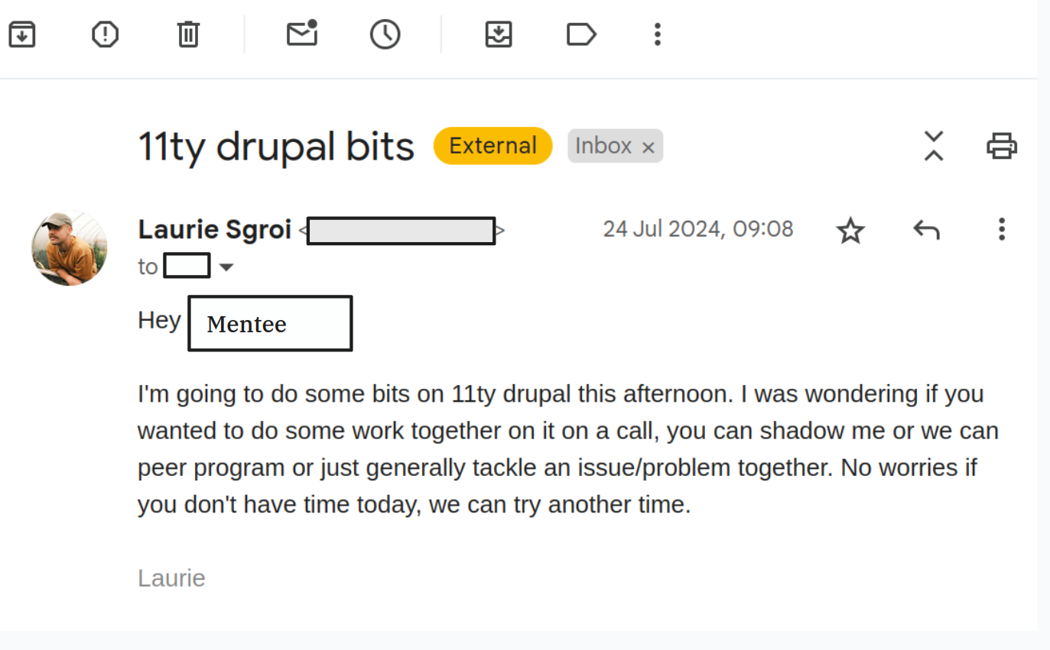
Figure 25 - Organising a mentor session during work on the 11ty - Drupal starter kit

